All Green Group homework for week beginning 3rd September 2018
Primary 2 GreenHomework – Please encourage your child to learn the homework words using the Look/ say / cover/ write and check strategy.
Monday:
- Write half of your spelling words in your jotter 3 times. (Look/ Say / Cover / Write and Check)
- Read and discuss pages 1-6 of your book.
- Mental Maths – maths grid (also on the blog- Mondays column please check your child’s numeracy group name; it is in their diary)
Tuesday:
- Complete your active spelling task with half of your words only ( you choose 5 words)
- Read and discuss pages 7-12 of your book.
- Mental Maths – maths grid (also on the blog) Tuesdays column
Wednesday:
- Write the second half of your spelling words in your jotter 3 times.
(Look/ Say / Cover / Write and Check)
- Read and discuss pages 13- end of your book.
- Mental Maths – maths grid (also on the blog) Wednesdays column
Thursday:
- Please LEARN your spelling words for Friday’s assessment.
- Read and discuss the whole reading book.
- Mental Maths – maths grid (also on the blog) Thursdays column
Friday: Hand in completed homework; signed by parent/carer. Please also sign the homework diary weekly.
GreenGroup - Active Spelling Task- write this in your jotter.

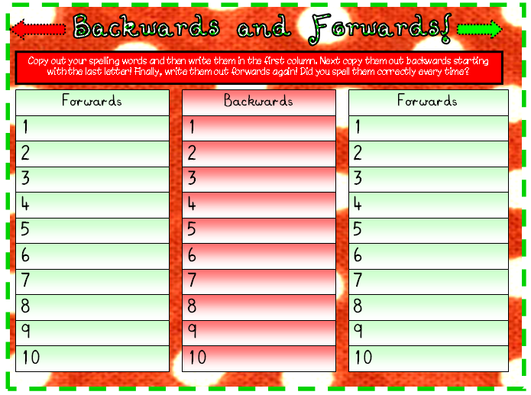

GreenSpelling Words | Wk beg 3rd September 2018 | my (Wednesday)
are (Monday) | has ( Monday) | me (Wednesday)
want (Monday) | like (Monday) | the (Wednesday)
all (Monday) | saw (Wednesday) | was (Wednesday)
Information for parents / carers below:

**** You will note that this week’s words are mostly the same tricky words as last week. Friday’s assessment has shown that unfortunately the children were not able to spell most of the homework words accurately so it is best that we ‘have another go’ at learning them. Please could I request that you support your child in learning the homework words; this will help them to gain a little more confidence in all areas of literacy.
- Some of the children have asked about accessing ‘Hit the Button’ maths game at home as they are also having fun with this in class. The link for this is https://www.topmarks.co.uk/maths-games/hit-the-button

- We will be working on Number Talks strategies in class this term which will focus on mental maths strategies. These are; to use fingers to count on and back/ start with the biggest number/ keep the biggest number in your head and count on/ find two numbers that make a 10/ adding numbers can be added in any order / when adding 9 we can add 10 and take one away. When working with your child at home, please encourage these strategies when you can.

- We have an Open Classroom Day on Wednesday of this week. All are welcome on that day- I look forward to seeing you all then.

