Primary 2 All Groups Homework – Wk Beg 27th Aug
Monday:
- Write half of your spelling words in your jotter 3 times. (Look/ Cover/ Write/ Say and Check)
- Read and discuss pages 1-6 of your reading book.
- Mental Maths grid; column 1 – Monday – calculate mentally.
Tuesday:
- Complete your active spelling task with Monday’s words only.
- Read and discuss pages 7-12 of your reading book.
- Mental Maths grid; column 2 – Tuesday – calculate mentally.
Wednesday:
- Write the second half of your spelling words in your jotter 3 times. (Look/ Cover/ Write/ Say and Check)
- Read and discuss pages 13 to end of your reading book.
- Mental Maths grid; column 3 – Wednesday – calculate mentally.
Thursday:
- Complete your active spelling task with Wednesday’s words only.
- Read whole book of your reading book.
- Mental Maths grid; column 4 – Thursday – calculate mentally.
Friday:
Hand in completed homework; signed by parent/carer. Please also sign the homework diary weekly.
Mental Maths Grid- Please read the questions to your child as they need to develop the skills to listen to the question and calculate the answer mentally. Their answer should then be written by the adult on the sheet.
.
Active Spelling Task

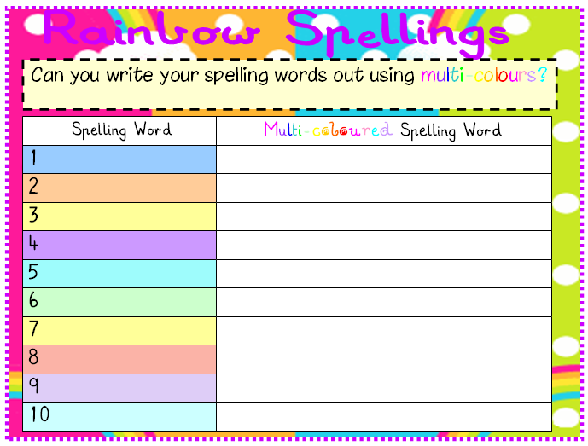

Weekly Spelling Words- Tricky words revision
was | has | like
saw | want | all
have | put | are
me

