All GreenGroup homework for week beginning 11th June 2018
Primary 2 GreenHomework – Wk Beg 11th June - Please encourage your child to learn the homework words using the Look/ say / cover/ write and check strategy.
Monday:
- Write half of your spelling words in your jotter 3 times.
(Look/ Say / Cover / Write and Check)
- Read and discuss pages 1-8 of your book.
- Mental Maths – Go on to ‘Hit the Button’ and play for 5 mins ( focus on doubles)
Tuesday:
Complete your active spelling task with half of your words only ( you choose 5 words)
- Read and discuss pages 9-16 of your book.
- Mental Maths – Go on to ‘Hit the Button’ and play for 5 mins ( focus on adding numbers beyond 20)
Wednesday:
- Write the second half of your spelling words in your jotter 3 times.
(Look/ Say / Cover / Write and Check)
- Read and discuss pages 17- end of your book.
- Mental Maths – Go on to ‘Hit the Button’ and play for 5 mins ( focus on doubles)
Thursday:
- Please LEARN your spelling words for Friday’s assessment.
- Read and discuss the whole reading book.
- Mental Maths – Go on to ‘Hit the Button’ and play for 5 mins ( focus on subtraction)
Friday: Hand in completed homework; signed by parent/carer. Please also sign the homework diary weekly.
GreenGroup - Active Spelling Task- write this in your jotter.

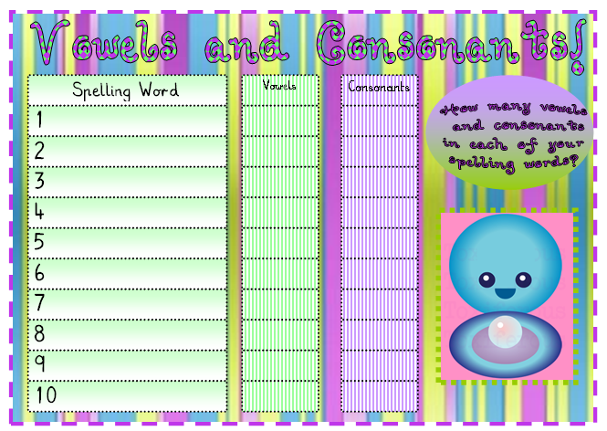

GreenGroup Spelling Words  (‘colour ’ words) | Wk beg 11th June 2018 | their (Wednesday)
blue(Monday) | black( Monday) | who(Wednesday)
orange(Monday) | colour(Monday) | when (Wednesday)
grey(Monday) | there(Wednesday) | where (Wednesday)

Dates For The Diary – Wk beginning 11th June
- Walk to school week this week- Please walk to school if you can. Please try to walk part of the way if you usually travel by car.
- Financial Numeracy Week – Money Sense volunteers to work with P1 and P2 in workshops about ‘How to Use Money.’
- Summer Reading Challenge- Children will be introduced to the ‘Summer Reading Challenge’ by a member of Giffnock Library.
- Primary 1 New Entrant Induction- on Thursday afternoon of this week.
- Winning House Day - Members of the Stevenson House to attend the winning house day at Culzean Castle Park (Your child will have received a letter if they are to attend this event.)

