All Green Group homework for week beginning 30th October 2017
Primary 2 Green Group Homework – Wk Beg 30th October-- Sorry for the mistake in the homework, we are all just getting used to this new way of working! The homework spelling should always come from the spelling words at the bottom of this sheet and not the reading book words which would be too tricky for the children. If you are having Halloween fun tonight and cannot manage the homework just leave it out for tonight- thanks again S Phee
Monday: Write half of your spelling words in your jotter 3 times. (Look/ Cover/ Write/ Say and Check)
Read and discuss pages 1-6 of your book.
Mental Maths – go on Sumdog and play for 5 mins.

Tuesday: Complete your active spelling task with Monday’s words only.
Read and discuss pages 7-11 of your book.
Mental Maths go on Sumdog and play for 5 mins.

Wednesday: Write the second half of your spelling words in your jotter 3 times. (Look/ Cover/ Write/ Say and Check) Read and discuss pages 12- end of your book.
Mental Maths – go on Sumdog and play for 5 mins.

Thursday: Complete your active spelling task with Wednesday’s words only.
Read whole book of your book.
Mental Maths – go on Sumdog and play for 5 mins.
Friday: Hand in completed homework; signed by parent/carer. Please also sign the homework diary weekly.
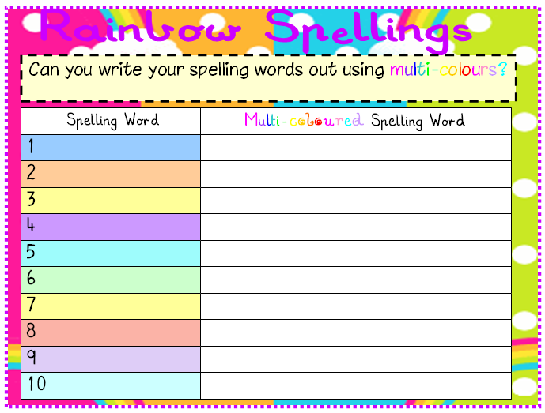
Green Group - Active Spelling Task- write this in your jotter.

Green Group Spelling Words | Wk beg 30th October 2017 | pub (Wednesday)
peg (Monday) | wet ( Monday) | sun (Wednesday)
pen (Monday) | sip (Monday) | rug (Wednesday)
set (Monday) | sit (Wednesday) | tut (Wednesday)
Please learn your words!
*** Please find below the link to the Christmas card competition which was discussed at assembly with Miss Cumming. The children were asked by Miss Cumming to make the Christmas Card for homework this week. Please have a go! https://blogs.glowscotland.org.uk/er/BraidbarPrimary/2017/10/25/whole-school-homework-task-christmas-card-competition/

