Home Learning Experiences – Friday 19th June
Life Skills
- Plan some fun activities for the weekend
- Tackle a job that you’ve been putting off
- Watch a film that you really enjoy OR one that you’ve never seen before!
- Teach someone in your family something you have learned during Home Learning

Literacy
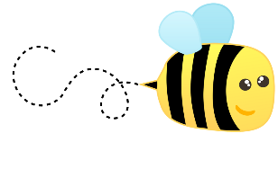
Spelling

Please ask an adult or a sibling to assist you with your spelling assessment.

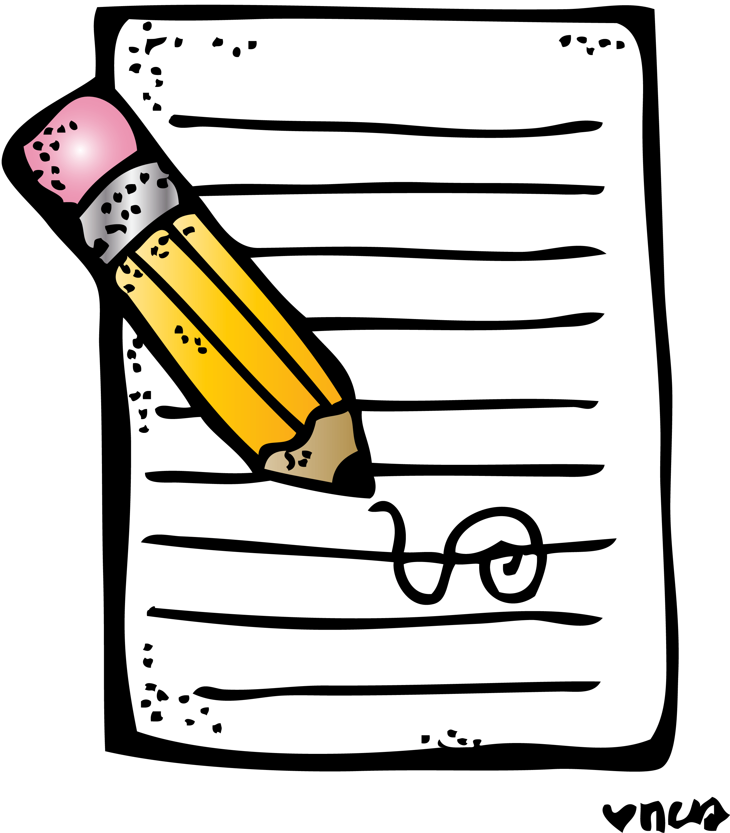
Writing

Please finish off and assess your work using the success criteria

Grammar

A really fab lesson all about synonyms and antonyms!

https://www.bbc.co.uk/bitesize/articles/zk23c7h

Numeracy and Maths
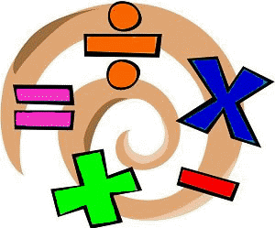
Please check your google classroom for today’s Problem Solving Home Learning Experiences.

Health and Wellbeing
Enjoy our amazing Joe Wicks ☺

https://www.youtube.com/watch?v=coC0eUSm-pc

Or alternatively try some of these amazing Dance Kids exercise videos if you feel like getting your dance on!

https://www.youtube.com/watch?v=sHd2s_saYsQ

Other Curricular Areas
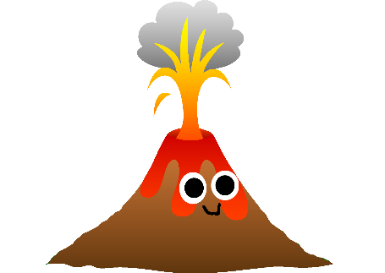
Geography

A really excellent lesson all about Volcanoes! One I know you will all enjoy

https://www.bbc.co.uk/bitesize/articles/zxwjr2p

Finishing off

We’ve had loads of work this week, so I’d like you to spend some time finishing off any tasks which have been started but not finished. It doesn’t need to just be tasks from this week, but any of the previous learning we have done.

Golden Time!

You know the drill! Have you earned your GT this week?

