Home Learning Experiences – Wednesday 17th June
Life Skills
- Help to load/unload the dishwasher or help wash the dishes
- Help to write the shopping list and work out the budget
- Do you earn pocket money? Discuss with mum and dad what jobs you’ll do to earn this
- Teach someone in your family something you have learned during Home Learning

Literacy
Reading

See our Reading Google Classroom for today’s reading task ☺
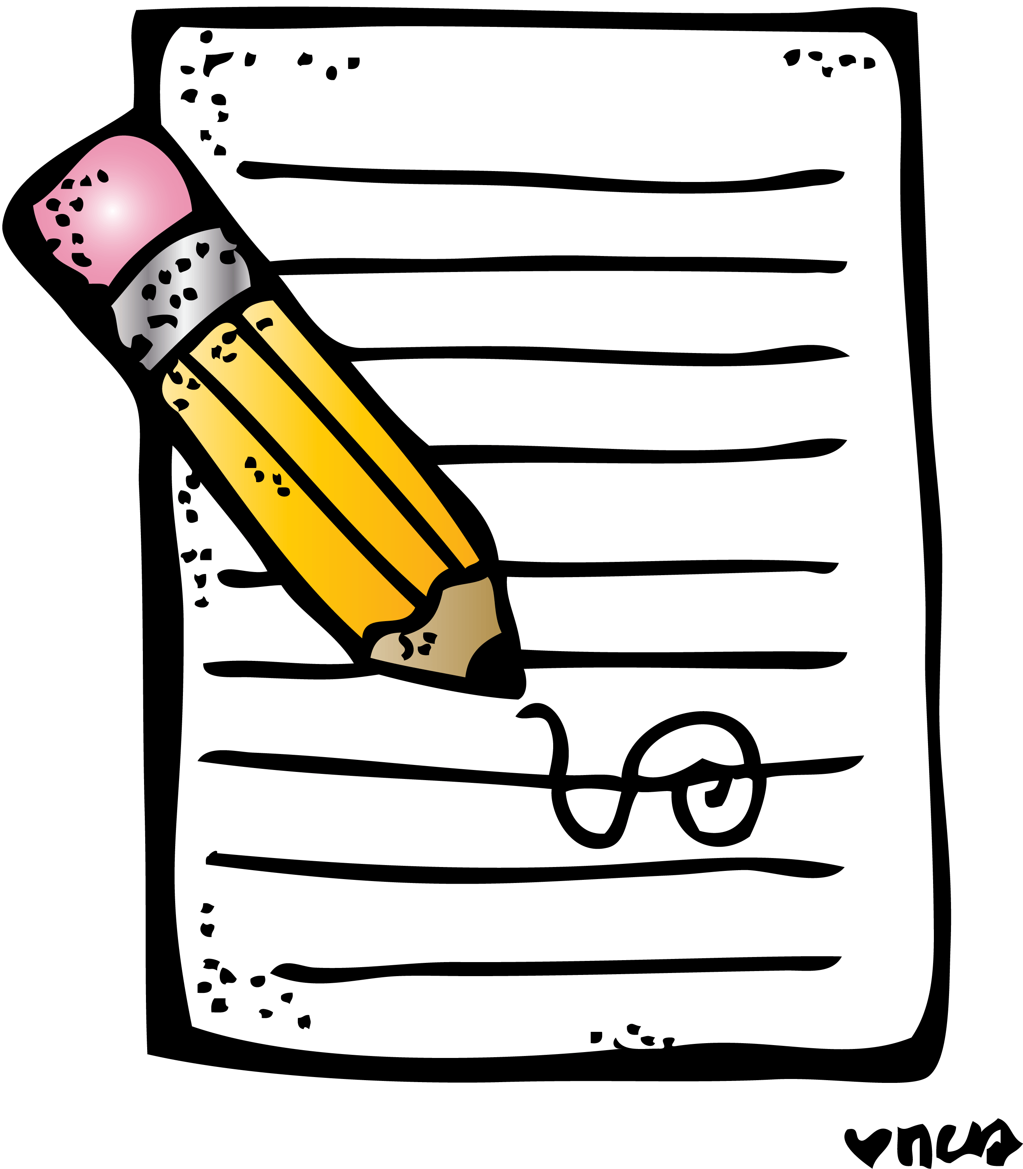
Writing

Our Writing task went on the Google Classroom yesterday. Make sure you stay up to date with this ☺

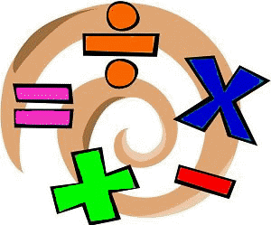
Numeracy and Maths
Please check your google classroom for today’s Numeracy and Maths Home Learning Experiences.

Health and Wellbeing
Enjoy our amazing Joe Wicks ☺

https://www.youtube.com/watch?v=coC0eUSm-pc

Or alternatively try some of these amazing short Zumba videos if you feel like getting your dance on!

https://www.youtube.com/watch?v=ymigWt5TOV8

Other Curricular Areas
Profiles

Keep working on your amazing profiles! I would like to see at least two new entries of something that you’ve learned about since working from home. Remember, this can be anything in literacy, maths, HWB or any other curricular area!

Social Space

I wasn’t planning on doing a Social Space this week but as Meet the Teacher has been rescheduled or next week I thought this could be our last session ☺ Chat between 10 and 11. Can’t wait!

