Home Learning Experiences – Tuesday 16th June
Life Skills
- Help to load/unload the dishwasher or help wash the dishes
- Play your favourite game outside
- Watch Newsround and read some of the related articles
- Teach someone in your family something you have learned during Home Learning

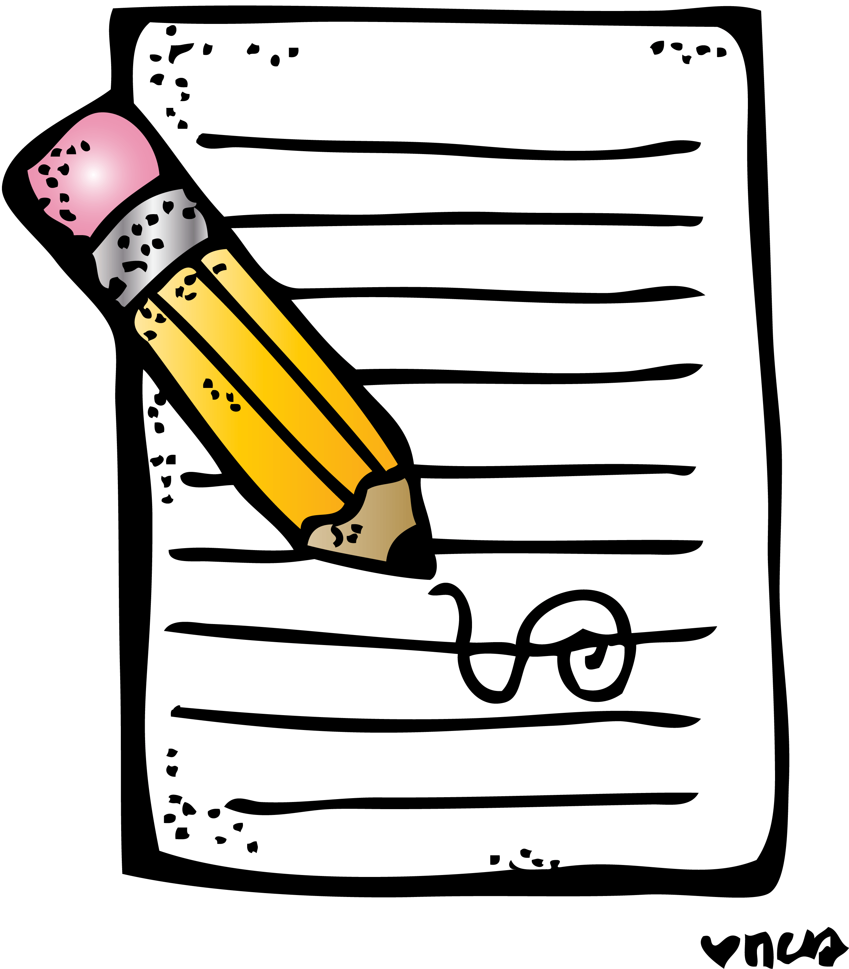
Literacy
Writing

Check out our Writing Google Classroom for this week’s writing task

Grammar and English

A wonderful lesson about using a Thesaurus from our friends at BBC Bitesize!

https://www.bbc.co.uk/bitesize/articles/zf96ncw

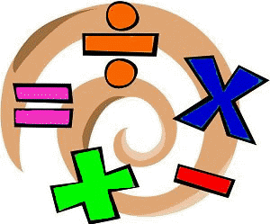
Numeracy and Maths
Please check your google classroom for today’s Numeracy and Maths Home Learning Experiences.

Health and Wellbeing
Enjoy our amazing Joe Wicks

https://www.youtube.com/watch?v=coC0eUSm-pc

Or alternatively try some of these amazing short Zumba videos if you feel like getting your dance on!

https://www.youtube.com/watch?v=ymigWt5TOV8

Other Curricular Areas
Science

I saw this brilliant lesson on BBC Bitesize all about renewable energies and I thought it would be a good one to do as it links to our previous topic, Climate Change.

https://www.bbc.co.uk/bitesize/articles/zm9jmyc

IDL

Please check our IDL Google Classroom for today’s IDL task

