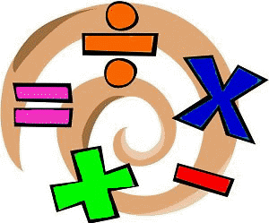
Home Learning Experiences – Thursday 11th June
Life Skills
- Spend time catching up on any work you haven’t completed yet
- Go for a walk in the park and count how many different ways you see people travelling (walking, jogging, scooting etc)
- Watch Newsround and read some of the related articles
- Spend some time playing your favourite game.

Literacy
Grammar

Lovely BBC Bitesize have got our grammar for today covered!
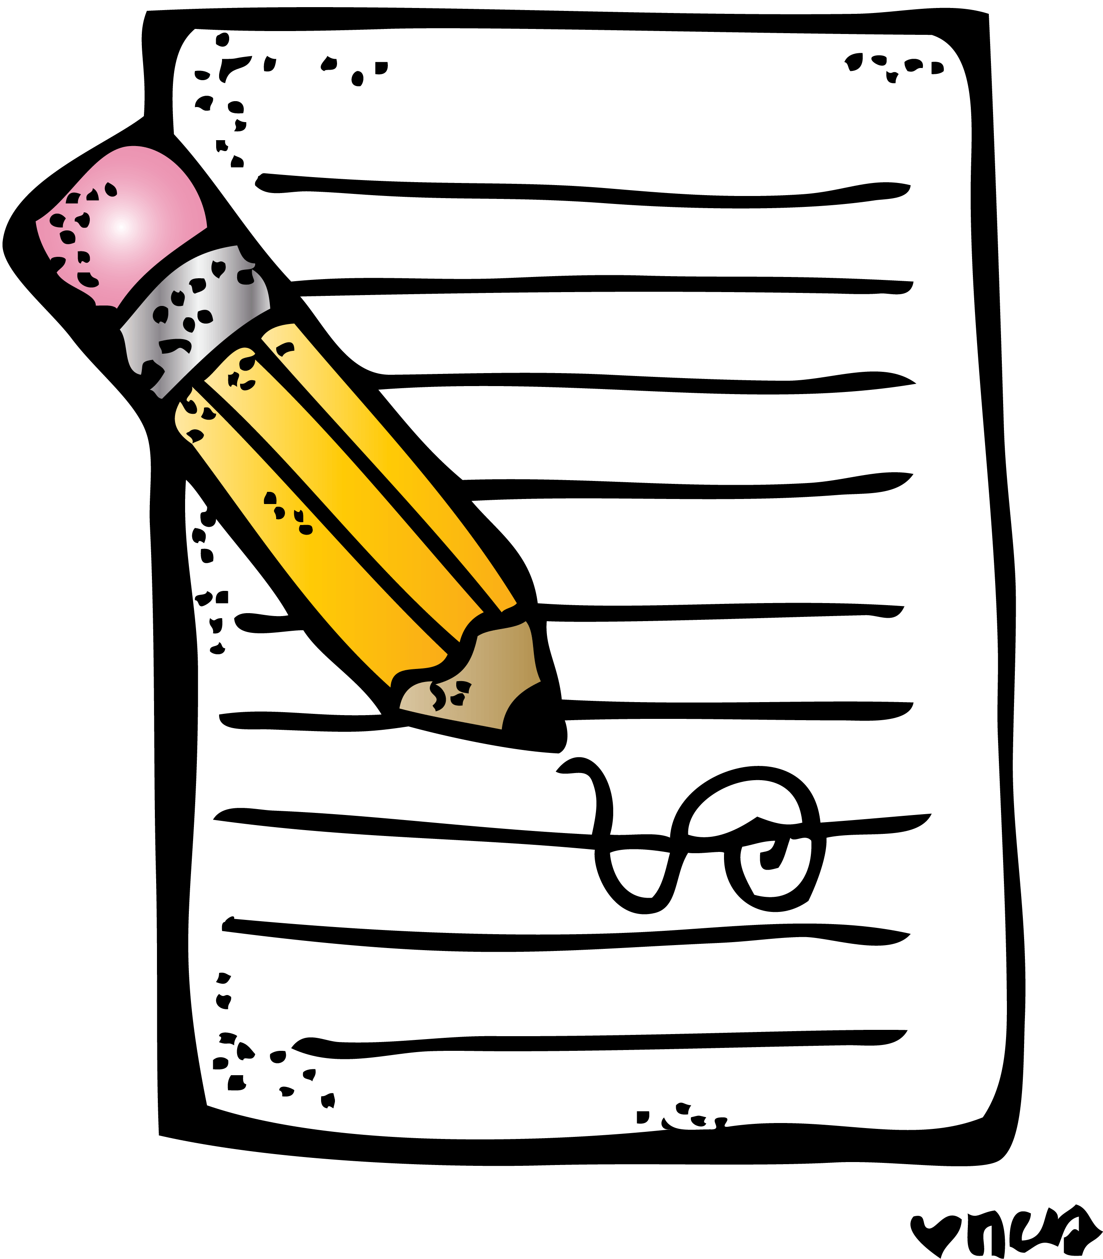
https://www.bbc.co.uk/bitesize/articles/zbvd7sg

Writing

Make sure you’re staying up to date with this week’s writing task.

Numeracy and Maths
Please check your google classroom for today’s STEM Home Learning Experiences.

Health and Wellbeing
Enjoy our amazing Joe Wicks

https://www.youtube.com/watch?v=coC0eUSm-pc

Or why not try a Just Dance or a Cosmic Kids yoga? The song in this Just Dance reminds me of you all!

https://www.youtube.com/watch?v=dnOL4V5_qaM
https://www.youtube.com/watch?v=tbCjkPlsaes
Other Curricular Areas
IDL

Check our IDL Classroom for todays task about the NHS

Art

On Tuesday many of you made an animation to summarise your book instead of doing a drama which I thought was a really great idea. The TATE have put together an amazing lesson all about animation which I thought you might want to try! You don’t need to make your model from plasticine, you can use Lego or any other figures that you have in the house.

https://www.tate.org.uk/kids/make/art-technology/be-animator
