Home Learning Experiences – Tuesday 9th June
Life Skills
- Spend time helping with a job in the garden
- Go for a walk and walk by the house of a friend or family member and wave in the window!
- Do some research into your dream job
- Watch Newsround and read some of the related articles

Literacy
Reading

Please find your updated reading pages for this week. Check out our Reading Google Classroom for today’s reading task

Rowlings – Friend or Foe, page 86 please.
Walliams – Christophes Story, page 52 please.
Dahls – Ottoline and the Yellow Cat, page 93 please.
Robins – The Owl who was afraid of the dark, page 53 please.
Morpurgos – The Photograph end of the book please.

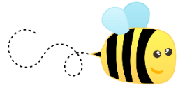
Writing

Check out our Writing Google Classroom for this week’s writing task

Numeracy and Maths
Please check your google classroom for today’s STEM Home Learning Experiences.

Health and Wellbeing
Enjoy our amazing Joe Wicks
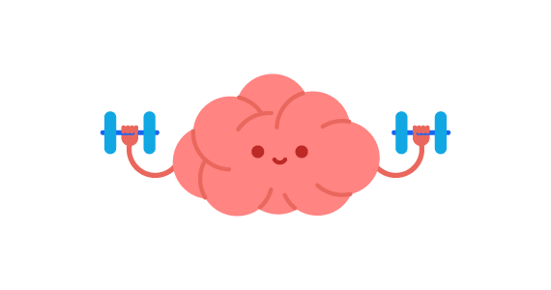
https://www.youtube.com/watch?v=coC0eUSm-pc

Growth Mindset

So last week we learned all about the brain, how we learn (new neurons in the brain) and the fact that we can actually make ourselves if we really practise and persevere with something. We also took a quiz which told us if we are a Growth or Fixed Mindset. Which one were you? Below I’ve included some phrases. I would like you to sort these into two columns. Do you think they are the statement of someone with a Growth Mindset or someone with a Fixed Mindset?

Other Curricular Areas
IDL

Please see your IFL classroom for today’s IDL task

History

Studying the Romans was ALMOST one of our IDL topics so I thought you would enjoy this lesson about their invasions from BBC Bitsize!

https://www.bbc.co.uk/bitesize/articles/ztryxbk

