Home Learning Experiences – Friday 5th June
Life Skills
- Help to plan a family meal
- Watch your favourite movie or play your favourite game
- Go for a walk and count all the different modes of transport you notice
- Draw a picture of someone who inspires you and think about why this is

Literacy
Reading

I was going to set some comprehension for you today based on the amazing questions which you created but many of you swapped with each other on Wednesday and so have actually already done your comprehension!

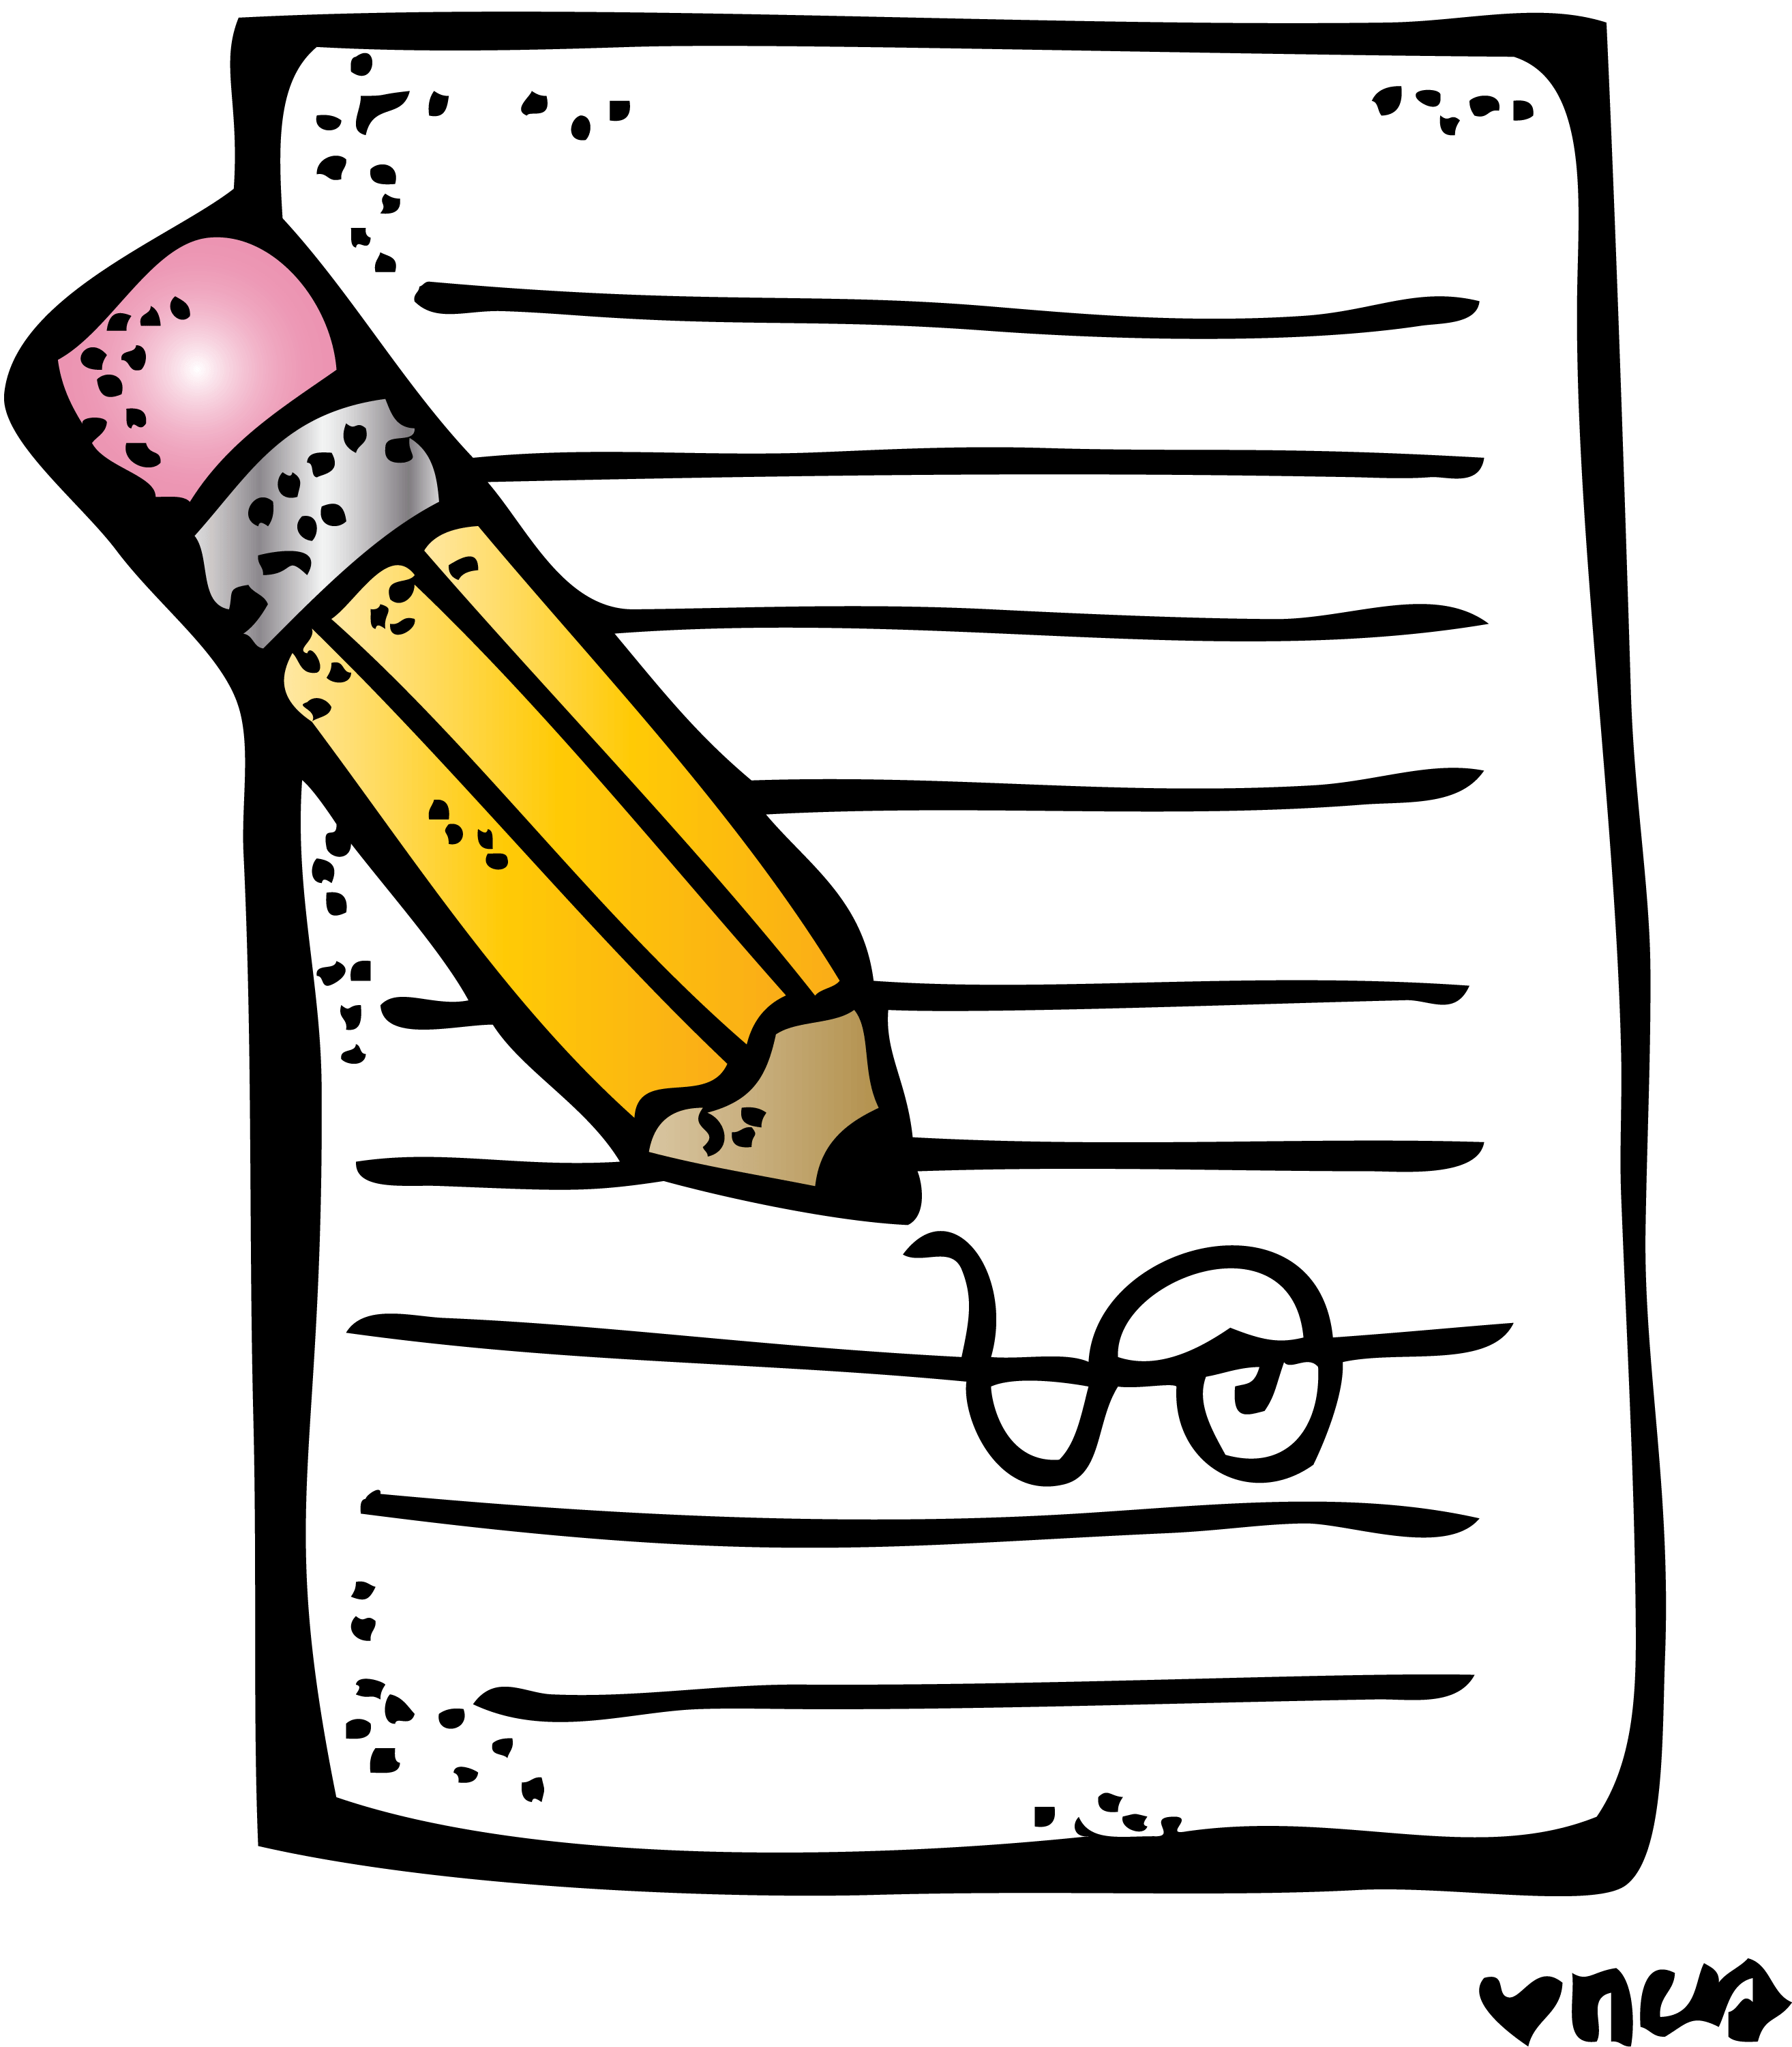
Instead I would love for you to write a summary about what you have read already This can done using tech or in your Literacy jotter and please feel to illustrate this too!

Writing

Today is our final day for writing so make sure you’ve got this completed. Can’t wait to read your reports.
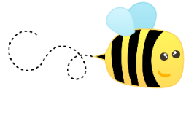
Spelling

Please ask an adult to help you with your spelling assessment.

Numeracy and Maths
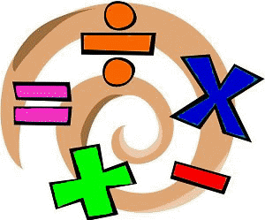
Please check your google classroom for today’s Problem Solving Home Learning Experiences.

Health and Wellbeing
Enjoy our amazing Joe Wicks
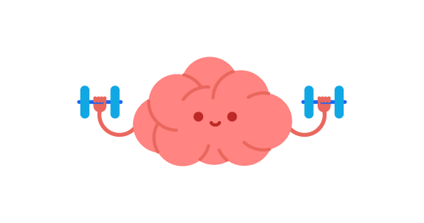
https://www.youtube.com/watch?v=coC0eUSm-pc

Growth Mindset

We now know that our amazing brain is actually a muscle which gets stronger the more we use it! I would like you to find out more about what the brain does. We know it’s in two halves. Can you please find out about what each side of the brain is responsible for? Draw a big brain in your IDL jotter and note down your notes inside that!

Other Curricular Areas
Art

I have loved looking through this amazing website for lots of ideas, and this open caught my eye! Can you please share your sound creatures with me?

https://www.tate.org.uk/kids/make/art-technology/draw-sound-creature

Golden Time

Another week of working exceptionally hard! I’m sure you’ve all earned your….
GOLDEN TIME!

