Home Learning Experiences – Thursday 4th June
Life Skills
- Help a sibling with their home learning or an adult in the house with a job that needs done
- Research ANYTHING you fancy
- Play a game which you came up with
- Help with the dishes or the washing

Literacy
Grammar

Revise your apostrophes with BBC Bitesize (I think I’m going to do this lesson too!)
https://www.bbc.co.uk/bitesize/articles/z7hxhbk

Writing

Please continue your writing for the week – details on the google classroom as normal.
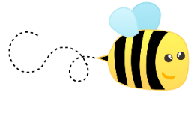
Spelling

Please spend some time practising your spelling words today.

Numeracy and Maths
Please check your google classroom for today’s Maths Home Learning Experiences.
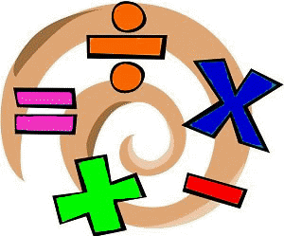

Health and Wellbeing
Enjoy our amazing Joe Wicks
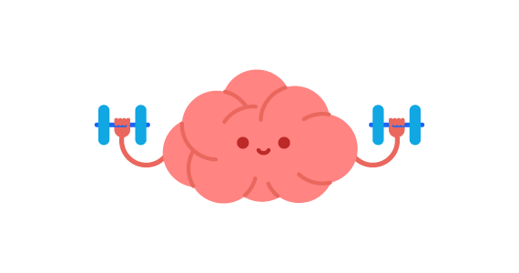
https://www.youtube.com/watch?v=coC0eUSm-pc

Growth Mindset

We’ve had LOADS to do with Growth Mindset over the past couple of days – spend some time catching up with anything you missed today

Other Curricular Areas
Science

A lot of you mentioned that you wanted to learn more about animals and BBC Bitesize is helping us out once again with an amazing science lesson focusing on food chains!

https://www.bbc.co.uk/bitesize/articles/zhnny9q

IDL

Check out our IDL classroom for details of our next topic and todays task

