Home Learning Experiences – Wednesday 3rd June
Life Skills
- Help a sibling with their home learning or an adult in the house with a job that needs done
- Research ANYTHING you fancy
- Play a game which you came up with
- Help with the dishes or the washing

Literacy
Reading

Can you please create 7 questions about your text? I’ll then gather these and use them for our comprehension on Friday See our google classroom for more information on this.

Writing

Please continue your writing for the week – details on the google classroom as normal.
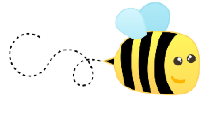
Spelling

Please spend some time practising your spelling words today.

Numeracy and Maths
Please check your google classroom for today’s Maths Home Learning Experiences.

Health and Wellbeing
Enjoy our amazing Joe Wicks
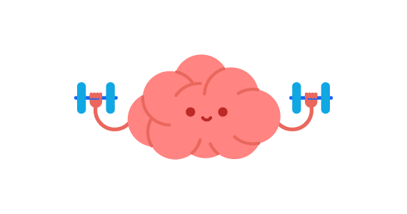
https://www.youtube.com/watch?v=coC0eUSm-pc

Growth Mindset

How did you get on yesterday finding out what type of mindset you are? Today we’re going to be looking more at the brain and how understanding that you can actually GROW your brain is crucial to having a growth mindset. Watch this little vid to find out more!

https://www.youtube.com/watch?v=EoWLgWCcpWo

These video tells you more about how the brain actually works. The more you practise a skill the more you strengthen your neural pathways! Even try making the brain in the second video if you fancy

https://www.youtube.com/watch?v=rf8FX2sI3gU

https://www.youtube.com/watch?v=mFuHKJqpxPw

Once you’ve watched these videos and had a think/chat about them, your task is to create ANYTHING – an advert, a poster, a lesson, a PowerPoint, a BRAIN - which will help you explain what you have learned to someone else! Can’t wait to see what you come up with!

Other Curricular Areas
Geography

I saw this lesson and thought that I might link to some of our learning in our IDL Climate Change topic – Enjoy

https://www.bbc.co.uk/bitesize/articles/zbwckmn

