Home Learning Experiences – Tuesday 2ndJune
Life Skills
- Write a list of things you would like to do in June
- Help a sibling with their home learning or an adult in the house with a job that needs done
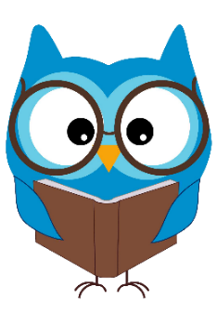
- Enjoy reading a book of your choice
- Play a game which you came up with

Literacy
Reading

If you haven’t already started your new reading pages please do so today.

Rowlings – Friend or Foe, page 48 please.
Walliams – Christophes Story, page 24 please.
Dahls – Ottoline and the Yellow Cat, page 41 please.
Robins – The Owl who was afraid of the dark, page 28 please.
Morpurgos – The Photograph, page 15 please.

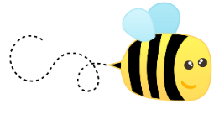
Writing

Please find this week’s writing task on our Writing Google Classroom.

Numeracy and Maths
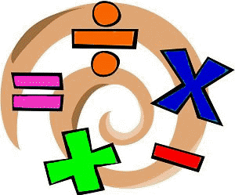
Please check your google classroom for today’s Maths Home Learning Experiences.

Health and Wellbeing
Enjoy our amazing Joe Wicks
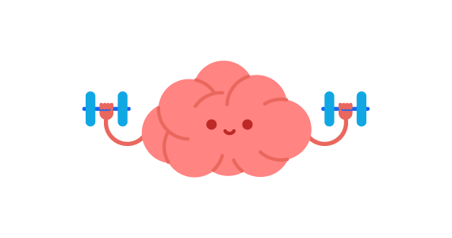
https://www.youtube.com/watch?v=coC0eUSm-pc

Growth Mindset

Along with the amazing motivation charts you have made, another really great way is to train yourself to have a growth mindset. We’ll be doing little growth mindset activities for the next few weeks before the end of term to help us stay motivated and to increase our growth mindset behaviours before we come back in August!

The first thing I would like you to do is think about the word MINDSET, GROWTH and FIXED? What do these words mean? Talk with adults in the house about what a growth mindset means and what a fixed mindset means? You can use the internet to help you research these terms too. Here’s a great video link also…

https://www.youtube.com/watch?v=2zrtHt3bBmQ

The second thing I would like you to do today is to find out what type of mindset you already have. Remember, there’s no right or wrong answer here and actually we all have different mindsets at different times.

https://wabisabilearning.com/blogs/mindfulness-wellbeing/growth-mindset-quiz

Other Curricular Areas
Art

I saw this beautiful art task and thought that it combined a few things that we had been working on already: re-using plastic and nature art! All you’ll need is an empty milk carton, some PVA glue, scissors and nature to make these beautiful outdoor/indoor lanterns (or they could be tubs for storing pencils/pens at your work station ) Send me photos of your results!

