Home Learning Experiences – Monday 1st June
Life Skills
- Draw a picture of what you got up to at the weekend
- Write a list of things you would like to do in June
- Help to prepare one of your family meals
- Write a list of new things you have learned since the start of lockdown.
- Help with a job in the garden

Literacy
Reading

Please find your reading for this week listed below. Why not find a nice spot in the garden or an outdoor space to enjoy your reading? Remember that you can use our Active Reading Strategy mats to help guide your reading session. These can be found in your homework diaries.

Rowlings – Friend or Foe, page 48 please.
Walliams – Christophes Story, page 24 please.
Dahls – Ottoline and the Yellow Cat, page 41 please.
Robins – The Owl who was afraid of the dark, page 28 please.
Morpurgos – The Photograph, page 15 please.

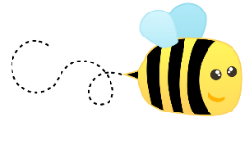
Spelling

Please kindly check your spelling words in the attached document (in the blog post) and practise these using an active spelling strategy of your choice.

Numeracy and Maths
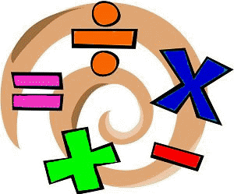
Please check your google classroom for today’s Maths Home Learning Experiences.

Health and Wellbeing
Enjoy our amazing Joe Wicks

https://www.youtube.com/watch?v=coC0eUSm-pc

Also try and use your amazingly designed motivation charts this week!
Other Curricular Areas
History

I know you loved finding out about how the Vikings lived, follow this link to find out about how life was in the Iron Age!
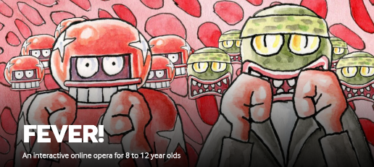
https://www.bbc.co.uk/bitesize/articles/zrv4dty

Drama

Follow this link to practise song 3 of your Fever! Performance

https://www.scottishopera.org.uk/join-in/fever-online/

