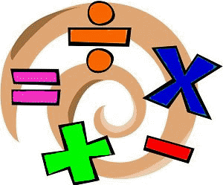
Home Learning Experiences – Friday 29th May
Life Skills
- Help to water the plants
- Spend time playing outside
- Plan enjoyable activities for the weekend
- Tidy your room and your workspace

Literacy
Writing

It’s our last day of ‘five objects’ writing so make sure you finish and assess your work. Thank you

Grammar

This this BBC Bitesize grammar lesson. Don’t be put off by the term ‘subordinating conjunction’ which sounds a bit scary. What that basically means is a connective and we know what connectives are!

https://www.bbc.co.uk/bitesize/articles/z6kj2sg

Numeracy and Maths
Please check your google classroom for today’s problem solving Home Learning Experience.

Health and Wellbeing
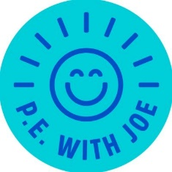
I’ve included the link for Joe Wicks but remember there are many alternatives out there if you wish to mix it up, what about trying a just dance?

https://www.youtube.com/watch?v=coC0eUSm-pc

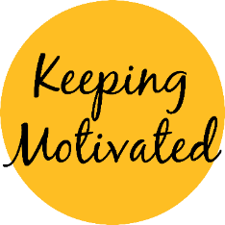
Please spend time today finishing off your motivation charts! Feel free to share pictures with me as I love seeing this

Other Curricular Areas
French
Choose any of the activities from the French Challenge Mat to enjoy!

IDL

Check our IDL classroom for one of our last Climate Change lessons

Golden Time

Have you worked hard this week? Have you earned your Golden Time? If you have please spend it outside! Have a fabulous weekend.

