Home Learning Experiences – Thursday 28th May
Life Skills
- Do whatever learning you can outside
- Help prepare a meal
- Help unload/load the dishwasher or help with the dishes
- Draw a picture of something which inspires you

Literacy
Writing

See our Writing Google Classroom for details of this week’s writing task

Reading

Please tackle page 26 and 27 of Nelson Comprehension Pupil Book 2 – I’ve put pictures of the text and questions on our Reading Google Classroom should you need these.

Numeracy and Maths
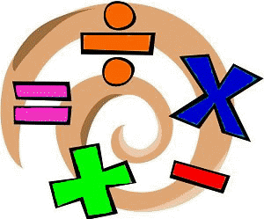
Please check your google classroom for today’s problem solving Home Learning Experience.

Health and Wellbeing
I’ve included the link for Joe Wicks but remember there are many alternatives out there if you wish to mix it up, what about trying a just dance?

https://www.youtube.com/watch?v=coC0eUSm-pc
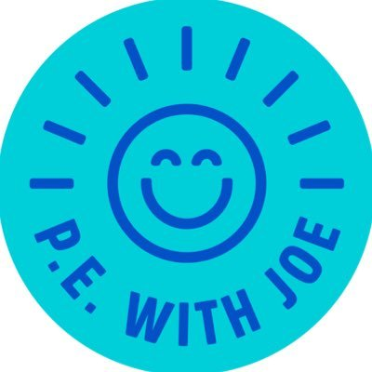

Well done for your hard work focusing on motivation yesterday – it was great to see some of the poster you designed.

Today we’re going to be using this information to create our own ‘Stay Motivated’ chart. It’s great to have a visual reminder to keep us on task.
This could look at a bit like a timetable, where you split your day into chunks of ‘home learning’. Each time you get through your home learning, you get a tick and then a treat – this can be something which motivates you! You can design this to look however you like, it’s your chart so something you are happy and proud to look at!
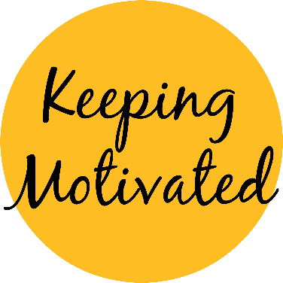

Other Curricular Areas
Art

As we started some French yesterday I thought this Art lesson would link in nicely!
https://www.bbc.co.uk/bitesize/articles/zjgj7nb

French

Choose any of the activities from the French Challenge Mat to enjoy!

IDL

Did you all managed to make a Wild Days account? Log back in and access any of the Climate Change activities which you haven’t already looked at

