Home Learning Experiences – Wednesday 27th May
Life Skills
- Do whatever learning you can outside
- Help prepare a meal
- Help unload/load the dishwasher or help with the dishes
- Draw a picture of something which inspires you

Literacy
Writing

See our Writing Google Classroom for details of this week’s writing task

Grammar and Handwriting

Please check our Reading Google Classroom for your grammar and handwriting task.

Numeracy and Maths
Please check your google classroom for today’s problem solving Home Learning Experience.

Health and Wellbeing
I’ve included the link for Joe Wicks but remember there are many alternatives out there if you wish to mix it up, what about trying a just dance?

https://www.youtube.com/watch?v=coC0eUSm-pc
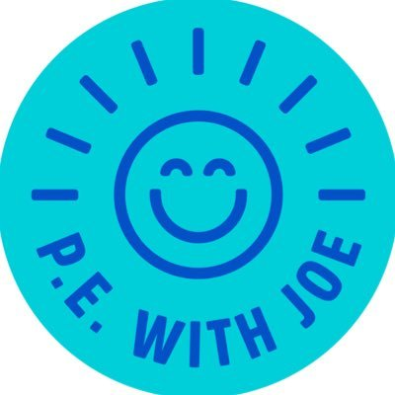

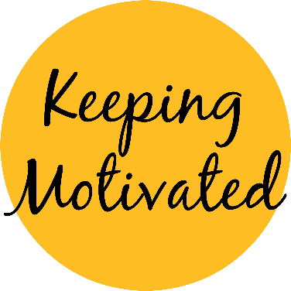
This is now week 10 of learning from home? Can you believe it! As it’s getting closer and closer to summer it’s becoming harder to stay motivated to keep learning, so that’s what we’re going to look at this week!
Today I would like you to research what does MOTIVATION actually mean? Think about things which motivate YOU? Then display this information on a poster – we’ll be using it in our motivation task tomorrow!

Other Curricular Areas
Drama/Science

This week’s song for fever is amazing! Find it under ‘song 2’ using the link below. There’s also a FANTASTIC science lesson to go along with the song this week so I strongly encourage you to give it a go
https://www.scottishopera.org.uk/join-in/fever-online/

French

Bonjour! We’ve been doing some Spanish recently, but it has been a while since we’ve looked at French.
Choose any of the activities from the French Challenge Mat to enjoy!

