Home Learning Experiences – Thursday 21st May
Life Skills
- Make something off your Happiness Bingo or May Calendar
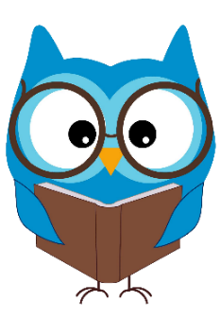
- Help with a job in the garden
- Plan some nice activities for the weekend
- Tidy up a messy drawer in the house

Literacy
Reading

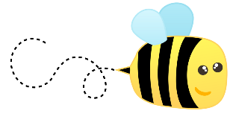
See our Reading Google Classroom for details of today’s reading task

Spelling

Can you please ask an adult to help you with your spelling assessment?

Numeracy and Maths
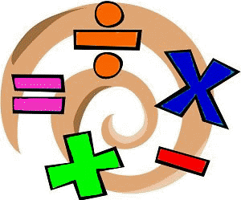
Please check your google classroom for today’s problem solving Home Learning Experience.

Health and Wellbeing
Links include Joe Wicks and East Renfrewshire Culture and Leisure Facebook page.

https://www.youtube.com/watch?v=coC0eUSm-pc

https://www.facebook.com/pg/ERCultureandLeisure/videos/?ref=page_internal

Also, please keep thinking about your Social Distancing P.E. Game challenge! What ideas have you come up with already?

Other Curricular Areas
IDL

Check out our IDL google classroom. I’ve put on a link to ‘wild days’ where you can sign up for free! They’ve got five different learning experiences all linked to climate change – choose one and follow along with the lesson!

Drama

We’ve still got our song from this week. If you haven’t tried it, give it go!
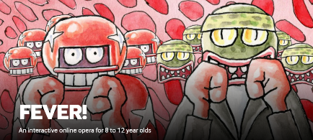
https://www.scottishopera.org.uk/join-in/fever-online/

Golden Time!

I realised that since we’ve started learning from home, I haven’t actually set a dedicated time for GOLDEN TIME! I think you have all definitely earned it. Golden Time, or any other kind of treat, is such a great way to motivate yourself to do the work so make sure you work hard to earn this special reward. What are you guys going to do for Golden Time?

