Home Learning Experiences – Wednesday 20th May
Life Skills
- Make a card for a member of your family and send it to them in the post
- Make something off your Happiness Bingo or May Calendar
- Help with a job around the house
- Finish some jobs that you started but didn’t complete
- Water your houseplants (if you have any!)

Literacy
Reading

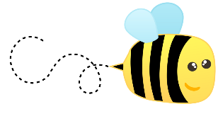
If you haven’t already made your novel inspired object then please do so today! See yesterday’s Home Learning Document for more details on this

Spelling

We’ll have our spelling assessment on Thursday this week so please spend some time doing active spelling – any strategy you fancy!

Talking and Listening/English

See this amazing BBC Bitesize English lesson which is all about formal and informal tone and language – a really handy one especially as we’re doing so much typing right now!

https://www.bbc.co.uk/bitesize/articles/zmnvgwx
Numeracy and Maths
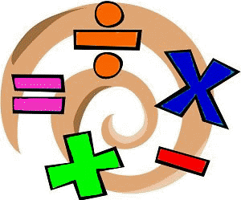
Please check your google classroom for today’s Maths Home Learning Experiences.

Health and Wellbeing
Links include Joe Wicks and East Renfrewshire Culture and Leisure Facebook page.

https://www.youtube.com/watch?v=coC0eUSm-pc

https://www.facebook.com/pg/ERCultureandLeisure/videos/?ref=page_internal

Also, I’ve been thinking about P.E. and games when we get back to school and I’m setting you a challenge:

Can you come up with a fun P.E. game which is quick, easy and active but also respects social distancing? Email me your thoughts and ideas and have a go of trialling them in your own gardens or outdoor space.

Other Curricular Areas
IDL

Keep going with that persuasion task! Check the classroom for details

Drama

We’ve still got our song from this week. If you haven’t tried it, give it go!
https://www.scottishopera.org.uk/join-in/fever-online/

Social Space

See you between 10 and 11 for some fabulous chats!

