Home Learning Experiences – Tuesday 19th May
Life Skills
- Make a card for a member of your family and send it to them in the post
- Make a list of things that you want to do today
- Help with a job around the house
- Play outside even if it’s raining!

Literacy
Reading

Your reading task for today and tomorrow is to create ANYTHING inspired by your novel. Maybe it’s something which you think one of the main characters needs? Maybe it’s something which was used or talked about in your book? Share a picture of your fabulous creations as well as a blurb of why you made this with me!?

Also, you have all done so much reading! Why don’t you just enjoy a story being read to you as it’s such a joy? Follow the link to find a selection of David Walliams book being read

https://www.worldofdavidwalliams.com/elevenses-catch-up/
Numeracy and Maths
Please check your google classroom for today’s Maths Home Learning Experiences.
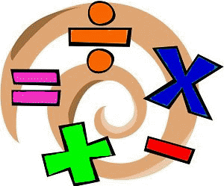

Health and Wellbeing
Enjoy our amazing Joe Wicks

https://www.youtube.com/watch?v=coC0eUSm-pc

I’ve attached the link for Facebook page for East Renfrewshire Culture and Leisure again – you’ll find loads of different exercise videos here to try out if you want to mix it up.

https://www.facebook.com/pg/ERCultureandLeisure/videos/?ref=page_internal

Other Curricular Areas
Drama

Did you start learning the amazing new song yesterday – it’s so catchy, it’s been in my head ever since! Please feel free to video yourself and send this on to me!

https://www.scottishopera.org.uk/join-in/fever-online/
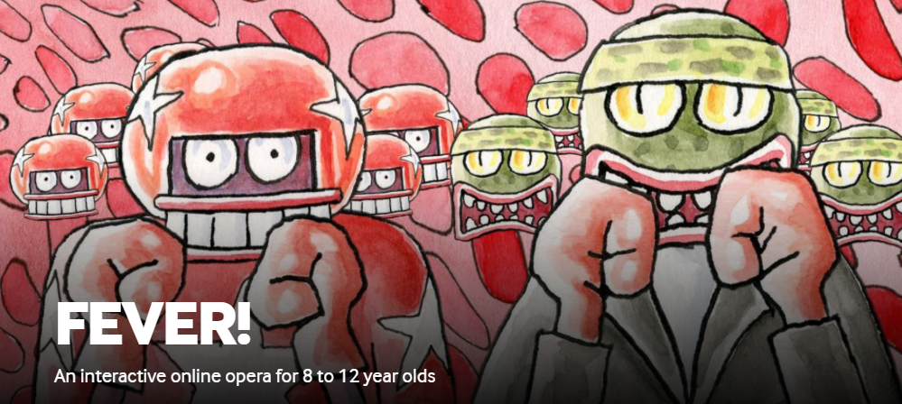

IDL

Check out our IDL classroom for today’s learning experience

