Home Learning Experiences – Monday 18th May
Life Skills
- Draw a picture of what you got up to at the weekend
- Help to prepare one of your family meals
- Write a list of new things you have learned since the start of lockdown #
- Help with a job in the garden

Literacy
Reading

Please find your reading for this week listed below. Rowlings, Walliams and Dahls – we’ll be starting a new book next week. This week we’ll be looking back at the Novels we’ve just finished so take time today to remind yourself of the main points and ideas of the book or to catch up with your reading pages. Try explaining or summarising to someone else in your family what the book is about.

Rowlings – Skim through Oranges in No Mans Land to remind yourself of the main ideas.
Walliams and Dahls – Skim through The Spiderwick Chronicles to remind yourself of the main ideas.
Robins – Care of Henry, page 40 please.
Morpurgos – End of the book please.

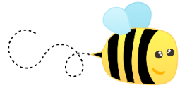
Spelling

Please kindly check your spelling words in the attached document (in the blog post) and practise these using an active spelling strategy of your choice.

Numeracy and Maths
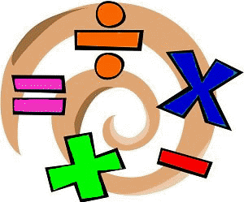
Please check your google classroom for today’s Maths Home Learning Experiences.

Health and Wellbeing
Enjoy our amazing Joe Wicks

https://www.youtube.com/watch?v=coC0eUSm-pc

I’ve attached the link for Facebook page for East Renfrewshire Culture and Leisure again – you’ll find loads of different exercise videos here to try out if you want to mix it up.

https://www.facebook.com/pg/ERCultureandLeisure/videos/?ref=page_internal

Other Curricular Areas
Science

As I know how much you all love animals, check out this lesson on vertebrates and in invertebrates on BBC Bitesize!

https://www.bbc.co.uk/bitesize/articles/zr4kd6f

Drama

Want the chance to be part of a live virtual performance in 5 weeks time!? Then these drama lessons are for you! Scottish Opera is arranging this amazing living Opera performance called Fever! Follow the link to find out more and to get practising song 1, ‘The Temperature is Rising’. I’ve also attached the song words to this blog post.

IDL

Did you all complete last week’s IDL task? It was a quite a big one – check the google classroom to remind you what you had to do!

