Home Learning Experiences – Friday 15th May
Life Skills
- Do you have a dishwasher? If so, find out how it works so that you can help with this job in the house. No dishwasher? Can you please clean whatever dishes are in the sink!
- Do you have a scooter or bike? Can you take that out for a scoot or cycle for exercise?
- Plan some enjoyable things to do this week. Mine is a takeaway from my favourite local restaurant!
- Plan a movie night for you and your family.

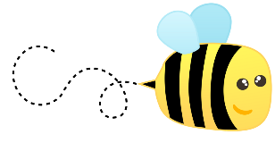
Literacy
Spelling

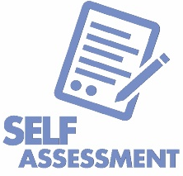
Please have an adult in your house help you with your spelling assessment.

Writing

Today your writing task is to self-assess your own work. Whenever you write anything (whether that’s a novel, an email, a letter, a to-do list) checking your work is the most important stage so please do not rush this! You are making sure that you are happy with what you have written, that it meets the brief and that it matches our success criteria – a very important skill so please take time with it

Numeracy and Maths
Please check your google classroom for today’s Problem Solving!
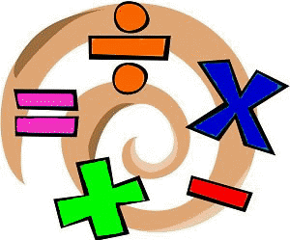
There’s also a SumDog competition starting today!
Can we make Braidbar number 1 – go for it team!!

Health and Wellbeing
Enjoy our amazing Joe Wicks

https://www.youtube.com/watch?v=coC0eUSm-pc

I’ve also attached another link which takes you to the Facebook page for East Renfrewshire Culture and Leisure – you’ll find loads of different exercise videos here to try out if you want to mix it up.

https://www.facebook.com/pg/ERCultureandLeisure/videos/?ref=page_internal

Other Curricular Areas
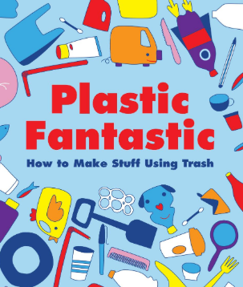
IDL
It was a pretty big task which we set out yesterday in IDL, so spend time today to continue with this! If you’ve already made a fantastic plastic creation is there another one that you can do?

Art

I have attached ‘Silly Sketch Ideas’ document to this blog post – check out this list of ideas of things to draw. Here is your challenge! Can you choose one of these MANY ideas and try drawing it four different ways? For example, one could be in black and white, one could be drawn with your eyes closed, one could be drawn without taking your pencil/pen off the page and the other could be painted? Below is the very famous Mona Lisa drawn several different ways! What will you come up with?
