Home Learning Experiences – Thursday 14th May
Life Skills
- Find out about how the washing machine works and see if you can put on a load of washing and then hang it out to dry
- Try and find 6 different ways of moving while out a walk today
- Mark something off you Happiness Bingo or the May Calendar
- Read a book of choice for pleasure or play your favourite board game
Literacy
Reading

For your reading task this morning I would like you to create a timeline of your book. The timeline should note the main events in the story in chronological order. Chronological means in the order that they happened.
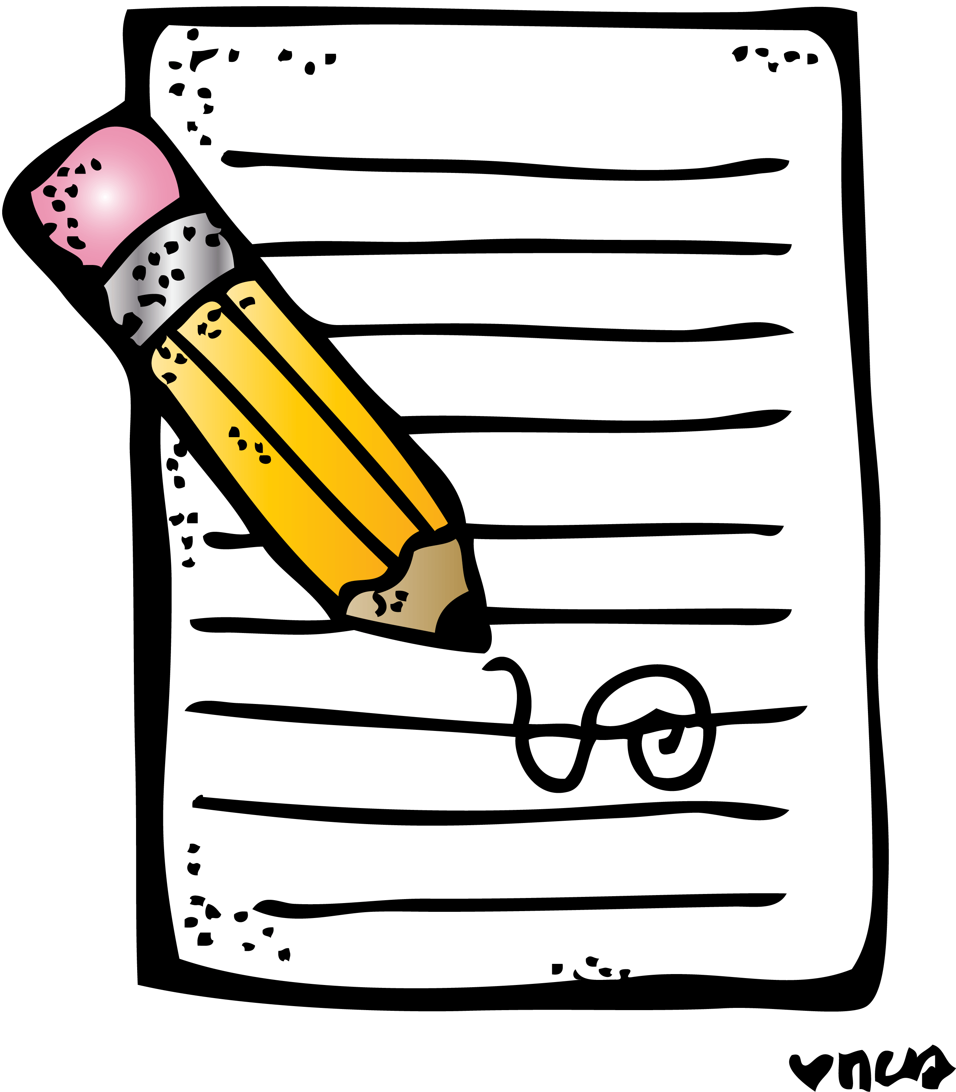
It also means that you might need to scan back in the book to remind yourself of when certain events happened.

Writing

Great progress with all your writing so far, keep checking the classroom to make sure you are progressing through

Numeracy and Maths
Please check your google classroom for today’s Maths Home Learning Activities.

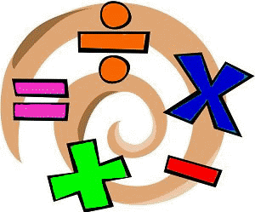

Health and Wellbeing
Enjoy our amazing Joe Wicks

https://www.youtube.com/watch?v=coC0eUSm-pc

I’ve also attached another video of some Strictly Stars doing a ‘Trolls’ inspired workout which I think I’m going to try today!

https://www.youtube.com/watch?v=MCeo6Q3p7Mc

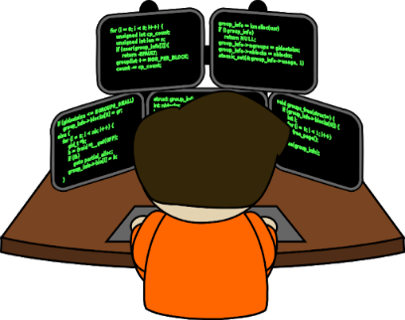
Other Curricular Areas
Coding

Mr Gordon has been so impressed with all your hard work in your Coding tasks, keep this up you lovely lot!

IDL

Check our IDL classroom for today’s new learning experience!
