Home Learning Experiences – Wednesday 13th May
Life Skills
- Spend 15 minutes relaxing by a window and count how many different things you notice
- Help mum or dad or a sibling with a job around the house
- Go for a walk and give say a kind hello to someone passing by
- Mark something off you Happiness Bingo or the May Calendar

Literacy
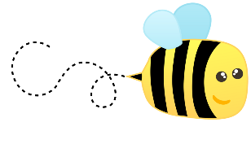
Spelling

Please spend some time practising your words using an active spelling strategy of your choice.

Grammar

We have already looked at similes and metaphors LOADS so this will be a nice refresher for you! Also, it might encourage you to include some of them in your writing this week. I used some in my description too! Can you find them?

https://www.bbc.co.uk/bitesize/articles/zk68wty

Writing

Check our Google Classroom for this week’s writing task

Numeracy and Maths
Please check your google classroom for today’s Maths Home Learning Activities.

Health and Wellbeing
Enjoy our amazing Joe Wicks Or you can try another online exercise video? Or just have a great time playing actively outside! Whatever lifts your heart rate is a good thing!

https://www.youtube.com/watch?v=coC0eUSm-pc

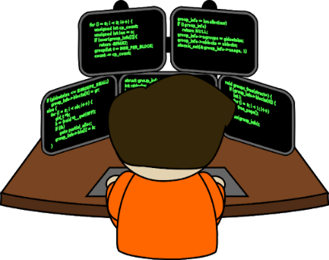
Other Curricular Areas
Coding

Mr Gordon has been so impressed with all your hard work in your Coding tasks, keep this up you lovely lot!

Social Space

Let’s get social with our Guest of Honour, Mrs Friel! See you at 10am for some new chats!

