Home Learning Experiences – Monday 11th May
Life Skills
- Finish a piece of work/job which you haven’t already completed
- Draw a picture of your long weekend
- Eat lunch outside and count how many birds, insects and animals you see
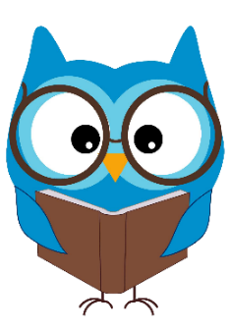
- Mark something off you Happiness Bingo or the May Calendar.

Literacy
Reading

Please find your reading for this week listed below. Where’s the comfiest place you can read? Can you make a den or find a cosy spot! Feel free to send me some pictures.

Rowlings – To the end of the book please.
Walliams and Dahls – To the end of the book please.
Robins – Care of Henry, page 20 please.
Morpurgos – Victorian Adventure, page 15 please.

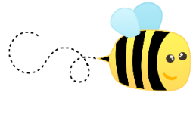
Spelling

Please kindly check your spelling words in the attached document (in the blog post) and practise these using an active spelling strategy of your choice.

Numeracy and Maths
Please check your google classroom for today’s Maths Problem Solving.

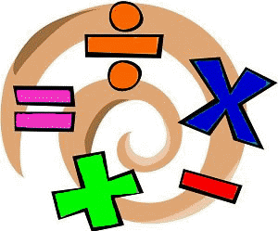

Health and Wellbeing
Enjoy our amazing Joe Wicks, I think I’ll be doing mine in the garden today even though it’s a little bit colder

https://www.youtube.com/watch?v=coC0eUSm-pc

Can you come up with your OWN alphabet challenge and share it with a friend?
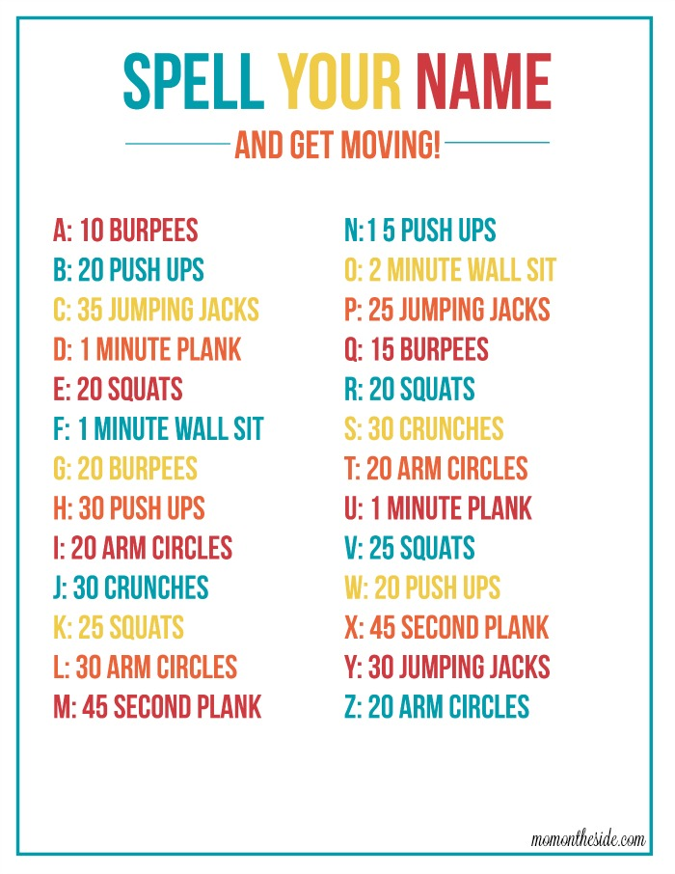

Other Curricular Areas
Science

Remember when Space was ALMOST our new topic? Well I’ve been keeping an eye out for space-relating things do that we can still do some learning in that area too! Check out this amazing lesson from Glasgow Science Centre about how to make your own star-scope.

https://www.glasgowsciencecentre.org/gsc-at-home/coming-soon

IDL

Did you all complete last week’s IDL task? It was a biggie – check the google classroom to remind you what you had to do and find today’s task there too!

