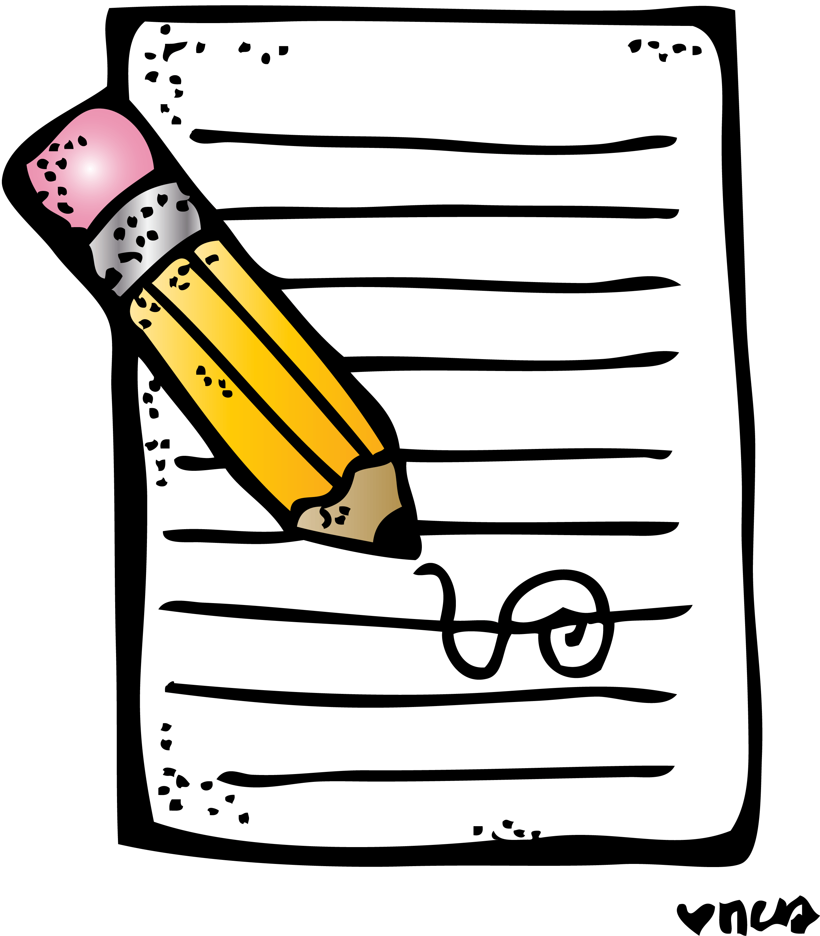
Home Learning Experiences – Tuesday 12th May
Life Skills
- Do a job which brings you lots of joy
- Draw a picture of your long weekend
- Go for a walk and give say a kind hello to someone passing by
- Mark something off you Happiness Bingo or the May Calendar

Literacy
Reading

Thanks for completing your reading pages yesterday. I’ve left the prescribed pages below in case you need to catch up!

Rowlings – To the end of the book please.
Walliams and Dahls – To the end of the book please.
Robins – Care of Henry, page 20 please.
Morpurgos – Victorian Adventure, page 15 please

For today’s reading task, can you please create a true or false quiz about what you have read and then swap with someone else in your reading group? You can do this online (create a Google Forms) or write in and then take a picture to send to/share with your friend. Or alternatively, share it with someone is your family who may also be reading your book with you!

Writing

Check our Google Classroom for this week’s writing task

Numeracy and Maths
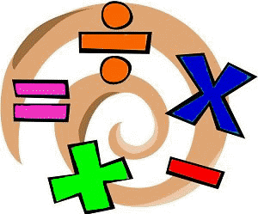
Please check your google classroom for today’s Maths Home Learning Activities.

Health and Wellbeing
Enjoy our amazing Joe Wicks Or you can try another online exercise video? Or just have a great time playing actively outside! Whatever lifts your heart rate is a good thing!

https://www.youtube.com/watch?v=coC0eUSm-pc

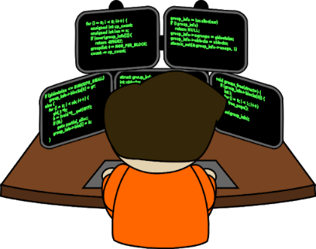
Other Curricular Areas
Coding

Mr Gordon has been so impressed with all your hard work in your Coding tasks, keep this up you lovely lot!

Spotlight Skills

CHALLENGE! You have £5 and you need to plan a dinner which you will cook for you and your family. Use the internet to research ingredients and prices and think about what your family would enjoy! You cannot just buy something which goes in the microwave! I’ve attached a document to the blog post, I’d like you to fill that out and return it to me please (Then I’ll have lots of tasty ideas for dinner too!)

