Spotlight Skills Come Dine with Me
The dinner I am going to make is:

The amount of people in my family is:

Before you start researching your dinner, remember to think about comparing prices across different supermarkets as you might be able to find some ingredients cheaper elsewhere.
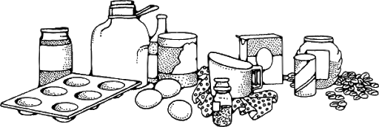

Item | Quantity | Shop | Price
Total Spend

Do you have any more money left? Would mum or dad be happy to extend your budget so that you can also plan, research and make a dessert?

Item | Quantity | Shop | Price
Total Spend

All finished? Please share your amazing recipes with me! And better yet, actually make this for your family and remember to send me lots of pictures!

