Home Learning Experiences – Wednesday 6th May
Life Skills
- Finish a piece of work/job which you haven’t already completed
- Plan something enjoyable to do on Thursday and Friday
- Eat lunch outside and count how many birds, insects and animals you see
- Spend time researching some POSITIVE stories about people helping with the corona virus.
- Mark something off you Happiness Bingo or the May Calendar.

Literacy
Reading

Thank you for all your wonderful summaries yesterday – these were of a great standard! For today’s reading task, can you choose one character in your book and create a poster all about them. This should include a picture of them, as well as a range of descriptive adjectives about them. It would be even better if you could justify WHY you have used these adjectives with points from the story

You can make this using digital technology or do it in your jotter, it’s up to you.
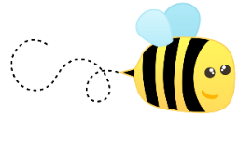
Spelling

Please kindly ask an adult if they can assess you on the spelling words which you have practised this week.

Numeracy and Maths
Please check your google classroom for today’s Maths Problem Solving.

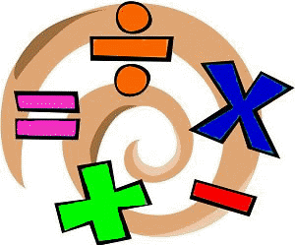

Health and Wellbeing
How was P.E. yesterday with Joe’s wife? Let me know and report progress with Mr Gordon

https://www.youtube.com/watch?v=coC0eUSm-pc

Or for a little change, try this one! Don’t just spell your own name, spell family member names too.
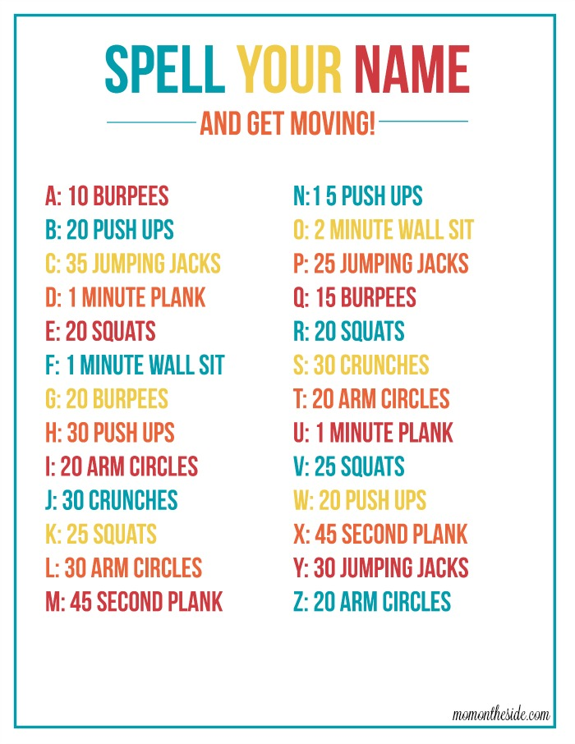

Other Curricular Areas
Social Space

I’ll be on our social space between 10 and 11 this morning! I look forward to chatting with you all there!

BBC Bitesize

Choose any lesson that interests you on BBC Bitesize and go for it! Let me know what challenges you decide on? I saw one about plants growing which I thought I might look in to!

https://www.bbc.co.uk/bitesize/tags/z63tt39/year-4-and-p5-lessons/1

