Home Learning Experiences – Tuesday 5th May
Life Skills
- Finish a piece of work/job which you haven’t already completed
- Help a sibling with their home learning, or help a parent with a job around the house
- Eat lunch outside and count how many birds, insects and animals you see
- Spend time researching some POSITIVE stories about people helping with the corona virus.
- Mark something off you Happiness Bingo or the May Calendar.

Literacy
Reading

Thanks for your visualisations yesterday, I loved seeing pictures of these! Please spend some time today to catch up with your reading today if you haven’t done so already. When you are finished, can you please write a summary of what you have read so far? Remember, you can use Somebody Wanted But So Then if you feel that this approach works. Please complete this in your jotter

Rowlings – page 76 please
Walliams and Dahls – page 77 please
Robins – end of the book please
Morpurgos – end of the book please
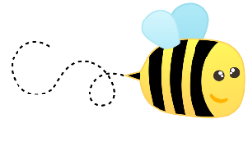
Spelling

Practise your chosen spelling words using an active strategy of your choice! Can it be one that you do outside?

Numeracy and Maths
Please check your google classroom for today’s Maths Home Learning.
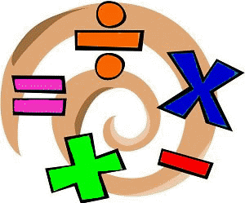

Health and Wellbeing
How was P.E. yesterday with Joe’s wife? Let me know and report progress with Mr Gordon

https://www.youtube.com/watch?v=coC0eUSm-pc

Alternatively, try any of these workouts…

https://www.youtube.com/watch?v=4ZpkRAcgws4
https://www.youtube.com/watch?v=7OyVX9Rs1yU

Other Curricular Areas
IDL

Please continue with yesterday’s IDL task. It was almost a three part activity (Research, note-taking and talking and listening skills) so please take until Wednesday to get this finished.

Art

Can you find 5 objects around the house and draw around these? These examples are in black and white but feel free to add any colour that you wish!

