Home Learning Experiences – Friday 1st May
Life Skills
- Plan something nice to do at the weekend
- Play a game which needs to be played outside
- Help a sibling with their home learning, or help a parent with a job around the house
- Do something which you know will make you calm and relaxed
- Help prepare lunch
Literacy
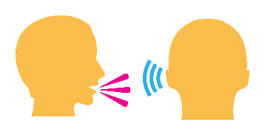
Talking and Listening

Today you have a talking and listening challenge, I’m setting you a secret mission to find out about the likes of your family members! Take time to have a conversation with every member of your family where you find out about their likes and interests - but you have to bring it in to conversation without them noticing! Use what you learn about them to design them a nice card or poster which will make them smile!

Spelling

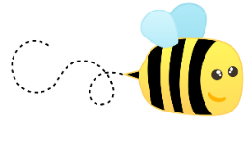
Please have an adult help you with your spelling assessment this week.

Numeracy and Maths
Please check your google classroom for today’s Maths Home Learning and Problem Solving.

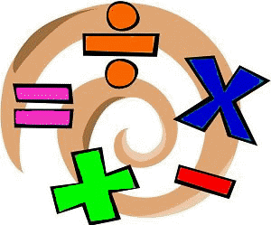

Health and Wellbeing
Enjoy your P.E. with Joe and post progress with Mr Gordon.

https://www.youtube.com/watch?v=coC0eUSm-pc

How are you getting on with the P.E. challenges? What ones have been trickiest so far? Feel free to send me pictures!
Other Curricular Areas
RME

Follow this fabulous BBC Bitesize link to find out more about the festival of Diwali

https://www.bbc.co.uk/bitesize/articles/z4dc47h

As many of you will know, Ramadan started last week on the 23rd April. Check out this Newsround video and Kiddle fact page to find out more! Or could you talk to anyone else in the class to find out more?

https://www.bbc.co.uk/newsround/23286976

https://kids.kiddle.co/Ramadan

IDL

It has been great to see some of the sways/PPs you have been working on about habitats and how they have been affected by climate change. Keep going with these and submit them today please

Art

The ‘class photo’ art task I set yesterday was a big one so take time to finish this off – pleeeease share your finished pieces with me, I’d absolutely love to see them!

