Home Learning Experiences – Wednesday 1st April
Life Skills
Happy April! Enjoy these life skill activities, try and do three a day!

- Start a brand new book of your choice
- Learn a new skill
- Help an adult in the house with a job
- Plan a healthy meal that the family can have this week
- Tell your family members three jokes as it’s April Fools Day!

Literacy
Reading

Thank you for all your hard work this week. As it’s Wednesday it’s time for our QUESTION CREATION! Please see your google classroom for more info.

Also, access this link to enjoy a live story from David Walliams!
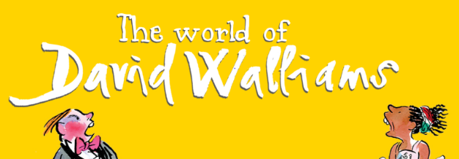
https://www.worldofdavidwalliams.com/elevenses/

Writing
Continue with your writing task for the week. You’ll find details of this on your google classroom

Numeracy and Maths
Please check your google classroom for today’s Maths Home Learning.

Health and Wellbeing
Joe Wicks is still available, so try that today and post about your progress on the ‘Team’!

https://www.youtube.com/channel/UCAxW1XT0iEJo0TYlRfn6rYQ

How are your gratitude journals going? Share your progress with me! Re-watch the video if you feel you need to.

https://www.youtube.com/watch?v=U5lZBjWDR_c

1. I am grateful for my two little cats around the house who are very cute.
2. I am grateful for face time and house party apps as these help me to keep in contact with my family.
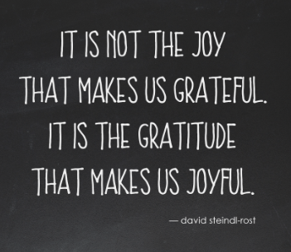
3. I am grateful that the house where I’m spending a lot of my time is safe and warm and comfortable.

Other Curricular Areas
IDL

Continue with your Viking explore project.

Technologies

Mr Gordon has very kindly set up a Code.org course for you! You can access this through Google Classroom and should contact him if you have any queries about logins Enjoy!

