Home Learning Experiences – Thursday 30th April
Life Skills
- Plan something nice to do at the weekend
- Play a game which needs to be played outside
- Help a sibling with their home learning, or help a parent with a job around the house
- Do something which you know will make you calm and relaxed
- Help prepare lunch
Literacy
Reading

As today is Captain Tom Moore’s 100th birthday, we’re going to be finding out more about him! See your Reading Google Classroom for a text and questions about this hero.

Spelling

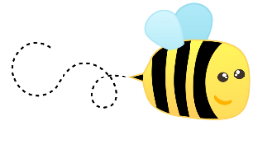
Please practise your spelling words using an active spelling strategy of your choice.

Numeracy and Maths
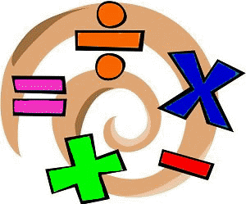
Please check your google classroom for today’s Maths Home Learning.

Health and Wellbeing
Enjoy your P.E. with Joe and post progress with Mr Gordon.

https://www.youtube.com/watch?v=coC0eUSm-pc

How are you getting on with the P.E. challenges? What ones have been trickiest so far? Feel free to send me pictures!
Other Curricular Areas
Coding

Enjoy some more Coding challenges with Mr Gordon !

IDL

It has been great to see some of the sways/PPs you have been working on about habitats and how they have been affected by climate change. Keep going with these

Art

Today was meant to be our class photograph () so I thought instead, we could all DRAW a class photograph. Remember to include all 28 of us! It’s up to you how you format this, as long as you take time to think about your class mates and what makes them all unique!

