Home Learning Experiences – Tuesday 28th April
Life Skills
Try and do three of these life skills each day…

- Organise a drawer in your bedroom
- Take the bins or the recycling out
- Offer to make an adult in your house a cup of tea (be careful with the kettle ) or a drink of their choice
- Try an online yoga or meditation video
Literacy
Reading

Well done on getting your reading completed yesterday! For today’s literacy task can you please create a comic strip which covers the main ideas of what have happened in your story so far?

Remember, the main ideas are not every single detail. These are the main things that have happened in the story, and the story could not progress without them.

Grammar

Please follow the link below for your grammar activity.
https://www.bbc.co.uk/bitesize/articles/zh8nscw
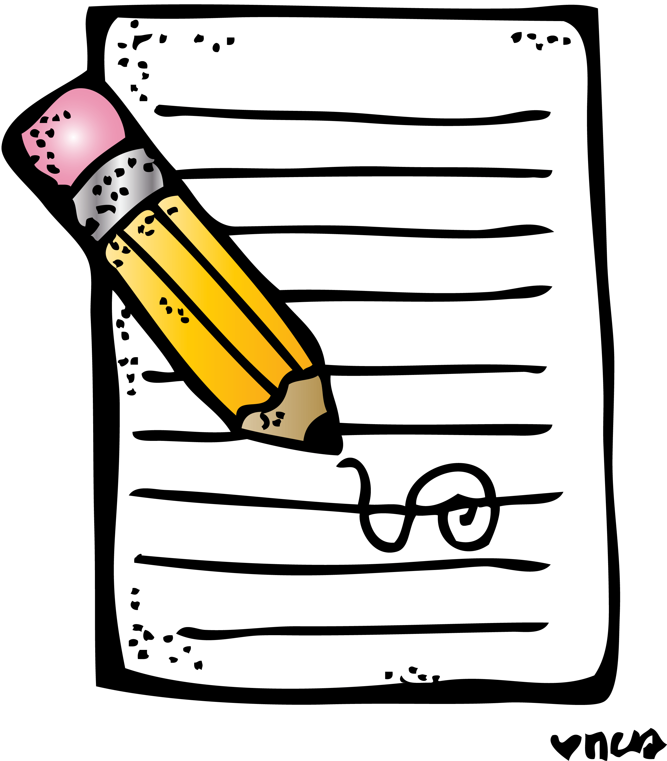
Writing

See this week’s writing task on our Writing Google Classroom.
Numeracy and Maths
Please check your google classroom for today’s Maths Home Learning.
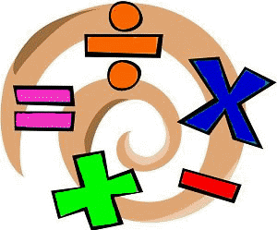

Health and Wellbeing
Enjoy your P.E. with Joe and post progress with Mr Gordon.

https://www.youtube.com/watch?v=coC0eUSm-pc

Can you complete two more challenges from our P.E. challenge board!? How did you get on with the ones from yesterday?
Other Curricular Areas
IDL

Please find todays IDL task on our Google Classroom.

Science

Choose one of the already shown amazing science videos from Glasgow Science Centre. Write down three facts and one opinion about the video you watched in your IDL jotter.

https://www.glasgowsciencecentre.org/gsc-at-home/enjoy-again

Coding

See our coding Google Classroom with Mr Gordon for coding challenges!

