Home Learning Experiences – Monday 27th April
Life Skills
Try and do some of these life skills each day…

- Mark something off your Happiness Bingo
- Ask a family member how they are
- Tidy your room
- Make a list of things that you are looking forward to doing after lockdown ends

Literacy
Reading

Please spend some time today to catch up with your reading. Why not make a comfy den to do your reading in?

Rowlings – page 60 please
Walliams and Dahls – page 59 please
Robins – page 35 please
Morpurgos – end of the book please
Spelling

I have attached this week’s spelling words in our blog post. Please practise these doing an active spelling strategy of your choice.

Writing

This week’s writing activity will be posted on our google classroom tomorrow!

Numeracy and Maths
Please check your google classroom for today’s Maths Home Learning.

Health and Wellbeing
Keep posting your Joe Wicks progress with Mr Gordon!

https://www.youtube.com/watch?v=coC0eUSm-pc

For our second HWB task this week I have attached a selection of ‘home challenges’. Can you master two of these challenges each day?
Other Curricular Areas
Science

Did you start the Nature challenge?! Keep going with this great work. For more information click the link below.

https://www.bnhc.org.uk/bioblitz-type/uk-city-nature-challenge/

Art

I’m sure you will all have seen the amazing Sir Tom Moore on the tv. This 99 year old war veteran has now raised £29,000,000,000 for NHS related charities! Amazing! It is his 100th birthday on Thursday, so we are going to make him a birthday card! This is an opportunity to think about a bright and eye-catching design, and also a kind message inside.

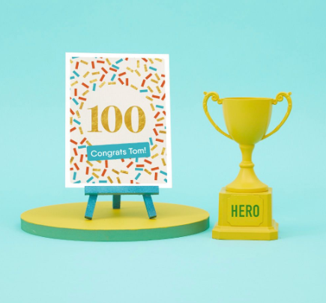
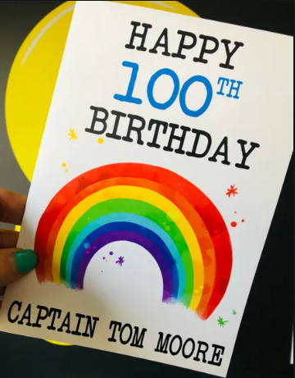
If you wish to send your card, the address is

Captain Tom Moore
C/O Marston Moretaine Post Office
67 Bedford Road
Marston Mortaine
Bedford
MK43 0LA

