Home Learning Experiences – Friday 24th April
Life Skills
- Create a new game and play it outside
- Help write the shopping list
- Help to plan meals for this week or next
- Organise some of your toys
- Plan two nice things to do at the weekend
Literacy
Reading

Please find your reading task on our google classroom today. Can you spot any of your own questions!?

Spelling
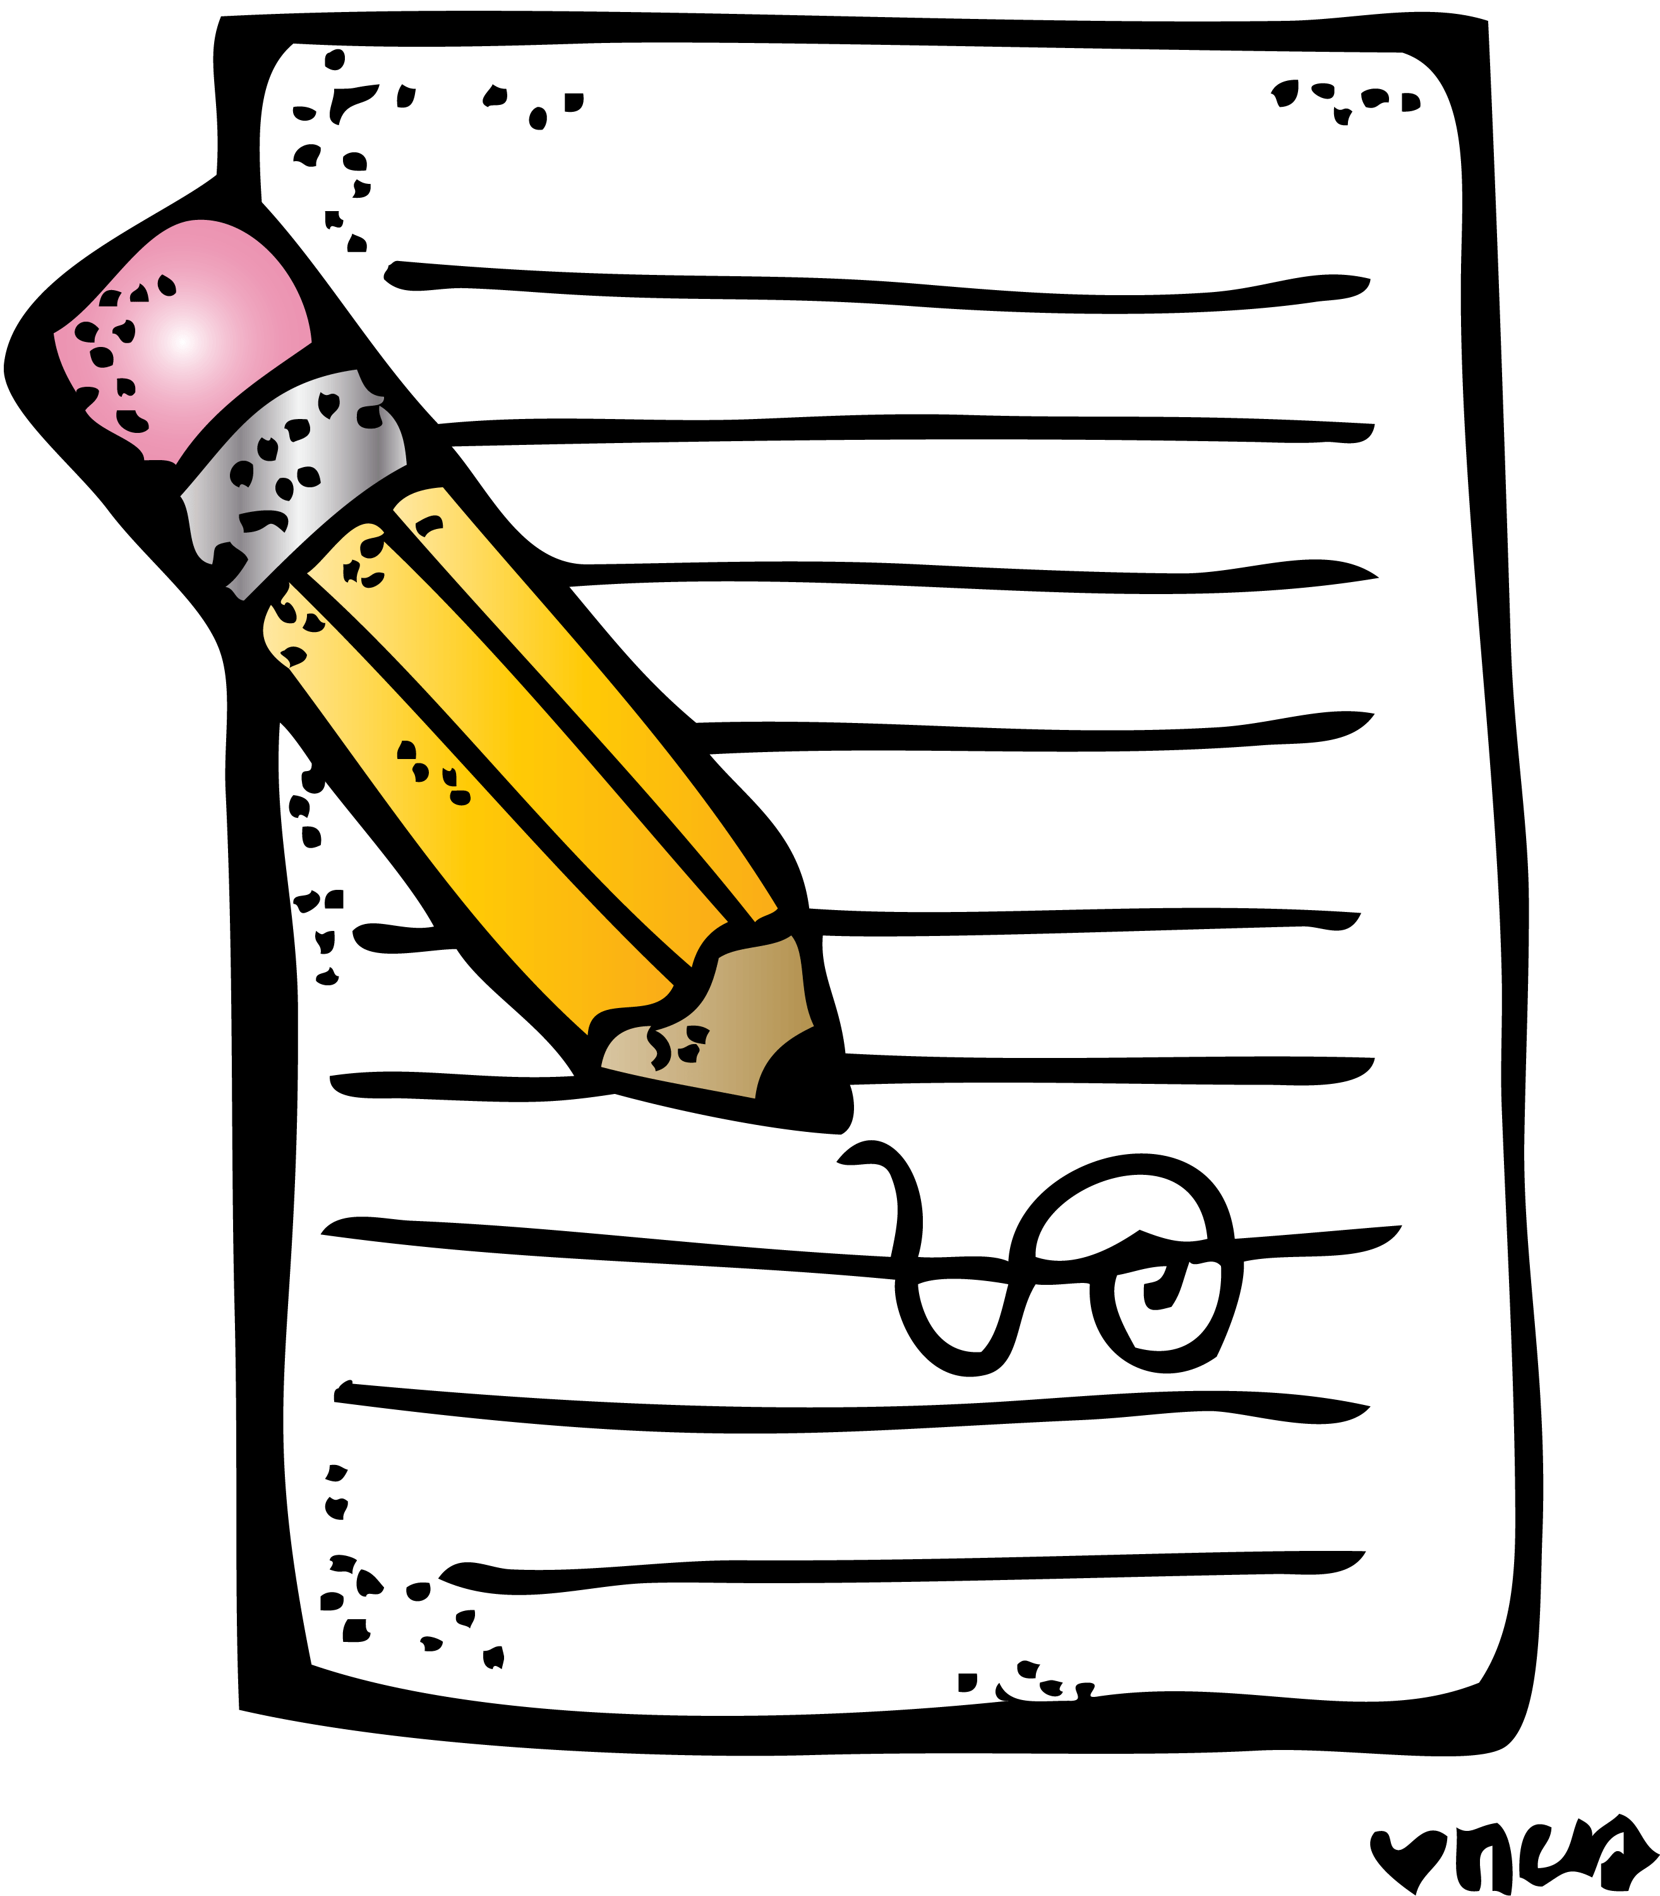
Please ask an adult to help you with your spelling assessment at a time which is convenient to them.

Writing
If you haven’t already submitted your writing please do so today

Numeracy and Maths
Please check your google classroom for today’s Problem Solving and answers for this week’s problems.

Health and Wellbeing
Enjoy today’s Joe Wicks!

https://www.youtube.com/watch?v=coC0eUSm-pc

PHOTO challenge!

I love these! Keep them coming! Share with me using the outlook tile on glow and send to my email, gw17macintyrelisa@glow.sch.uk

Here are photos of me enjoying my lunch time walk yesterday. Has anyone else noticed the beautiful cherry blossom trees?
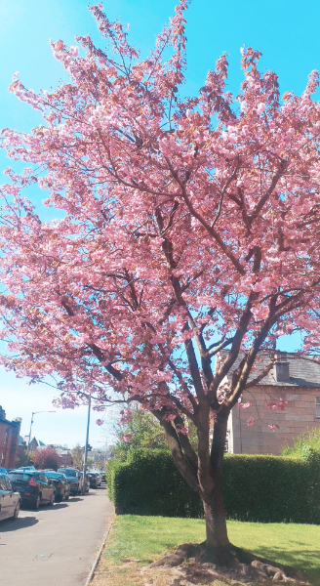
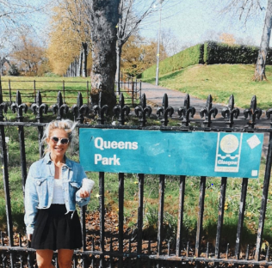

Other Curricular Areas
IDL

Thanks for all the amazing ideas! Please find your first IDL activity on our IDL google classroom

Science

Follow the following link to sign up for the UK City Nature Challenge which runs from today for the next week

https://www.bnhc.org.uk/bioblitz-type/uk-city-nature-challenge/

