Home Learning Experiences – Thursday 23rd April
Life Skills
- Choose a movie for you and your family to watch together
- Help write the shopping list
- Help to plan meals for this week or next
- Organise some of your toys
- Enjoy time outside (I will be!)
Literacy
Reading

Thank you for reading your specified pages and creating a selection of questions on these. Today I would like you watch an amazing authors live with Liz Pichon and have the opportunity to doodle along with her!

https://www.scottishbooktrust.com/authors-live-on-demand/liz-pichon

Spelling
Practise this week’s spelling words with an active spelling strategy of your choice. If you can do something outside then even better!

Numeracy and Maths
Please check your google classroom for today’s Maths Home Learning.

Health and Wellbeing
Enjoy today’s Joe Wicks!

https://www.youtube.com/watch?v=coC0eUSm-pc

PHOTO challenge!

I love these! Keep them coming! Share with me using the outlook tile on glow and send to my email, gw17macintyrelisa@glow.sch.uk

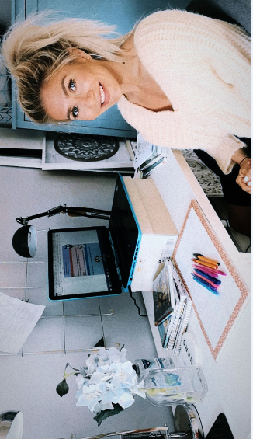
Today’s picture is of me at my work space. I am very lucky to have a home office so I can work from there without any distractions, but not everyone has this space! Where are you guys working? How are you organising your day. I like to break mine up with frequent tea/coffee breaks and a walk at lunch time.

Other Curricular Areas
IDL

Thank you to all of you have have submitted your planning grid for our new IDL topic, Climate Change and the Environment. There have been some fantastic ideas! If you haven’t already done that could you please complete it and submit so that I can make sure some of your ideas are involved in our planning

Music

I’ve included this lesson as it’s one that I’ll definitely be doing along with you all. As you know primary 5, I am not a good singer so today’s lesson on BBC bitesize will help us with this. Feel free to send through any videos of you singing

https://www.bbc.co.uk/bitesize/articles/z7xsf4j

