Home Learning Experiences – Wednesday 22nd April
Life Skills
- Choose a movie for you and your family to watch together
- Help write the shopping list
- Offer to make an adult in your house a cup of tea (be careful with the kettle ) or a drink of their choice
- Tidy up a room in your house
- Enjoy time outside (I will be!)
Literacy
Reading

Thank you for reading your specified pages Primary 5. If you haven’t already done so I’ve left note of these below. I’d like you to find your question creation task on google classroom today.

Rowlings – page 33 of Oranges in No Man’s Land
Walliams and Dahls – page 31 of the Spiderwick Chronicles
Robins – Page 15 of The Witches Dog and the Crystal Ball
Morpurgos – Page 17 of A Day in London
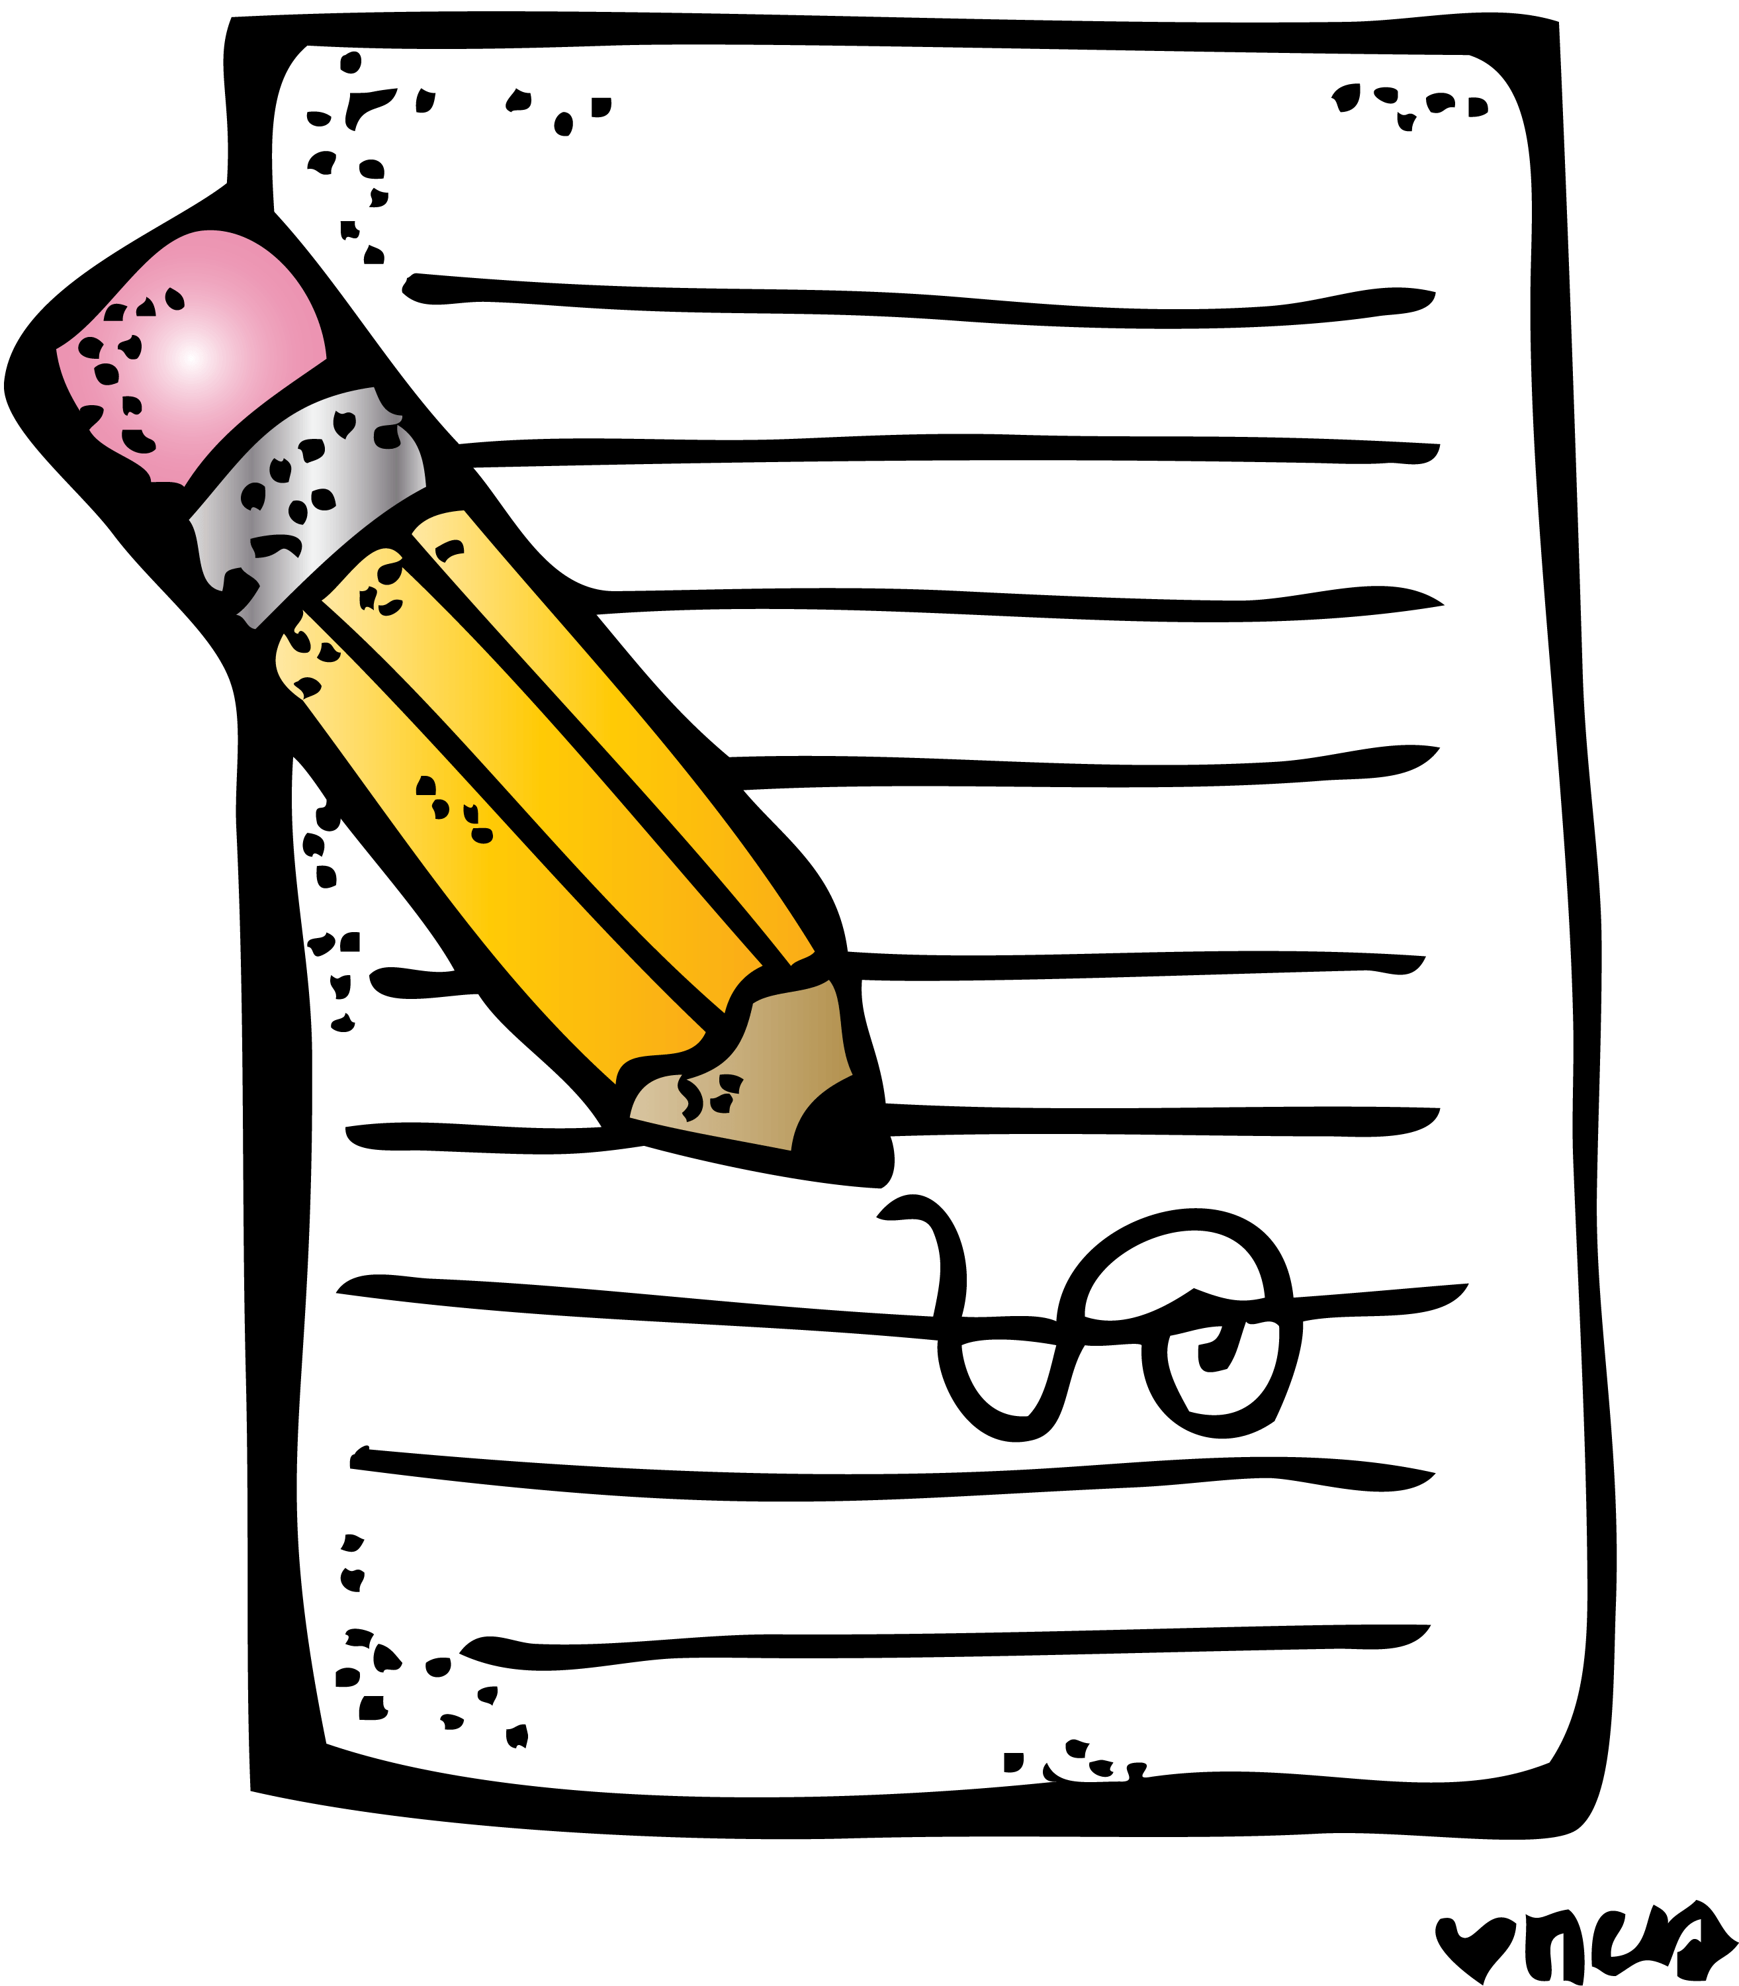
Writing
See this week’s writing task on our Writing Google Classroom.

Numeracy and Maths
Please check your google classroom for today’s Maths Home Learning.

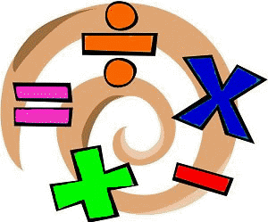

Health and Wellbeing
Enjoy today’s Joe Wicks!

https://www.youtube.com/watch?v=coC0eUSm-pc

PHOTO challenge!

I love these! Keep them coming! Share with me using the outlook tile on glow and send to my email, gw17macintyrelisa@glow.sch.uk

Today’s picture is of my ingredients of my dinner last night! I’ve been cooking lots since our lockdown life started. What have you guys been making?
I’ve also been playing some board games with my husband. One of my favourites is Game of Life. What board games have you played?
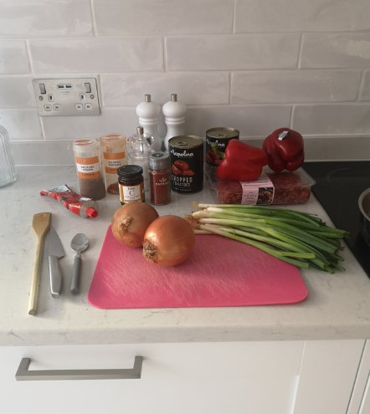

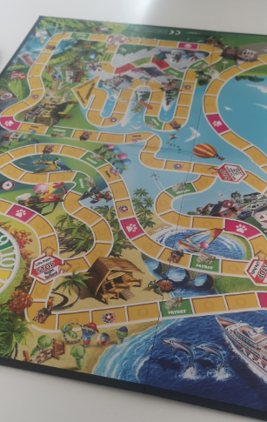

Other Curricular Areas
IDL

Please complete the planning sheet on our IDL google classroom. This is exactly like how we plan in class but sadly we’re not together to discuss things, so make sure you talk with your family to generate some good ideas!

Science

I noticed that a few of you mentioned that you would like to do Space as our next IDL topic. Follow this link for an amazing lesson all about light and dark in space. Enjoy!

https://www.bbc.co.uk/bitesize/articles/zhk2mfr

