Home Learning Experiences – Tuesday 21st April
Life Skills
Try and do three of these life skills each day…

- Eat your lunch outside picnic style!
- Find a comfy spot and read a book of your choice
- Offer to make an adult in your house a cup of tea (be careful with the kettle ) or a drink of their choice
- Tidy up a room in your house
- Enjoy time outside (I will be!)

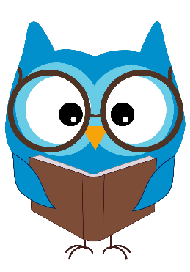
Literacy
Reading

Well done for all your hard work in your prediction and questions task yesterday! Today I would like you to start reading your new novels. I’ve specified pages below.

Rowlings – page 33 of Oranges in No Man’s Land
Walliams and Dahls – page 31 of the Spiderwick Chronicles
Robins – Page 15 of The Witches Dog and the Crystal Ball
Morpurgos – Page 17 of A Day in London

Grammar

Please follow the link below for your grammar activity.
https://www.bbc.co.uk/bitesize/articles/znpbgwx

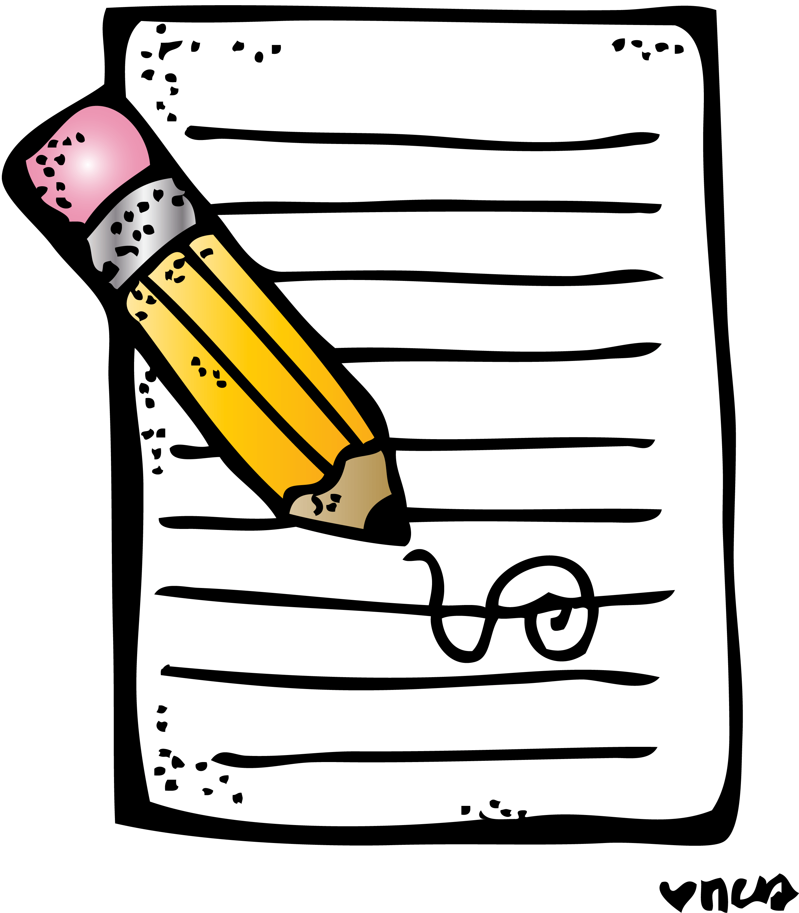
Writing

See this week’s writing task on our Writing Google Classroom.
Numeracy and Maths
Please check your google classroom for today’s Maths Home Learning.
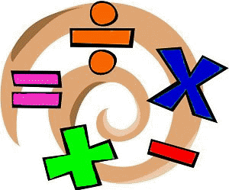

Health and Wellbeing
I’ve LOVED keeping up with Joe Wicks over our holidays, so feel free to join in with him this morning, posting your progress with Mr Gordon.

https://www.youtube.com/watch?v=coC0eUSm-pc

Our second HWB activity this week is going to be a PHOTO challenge! I LOVED seeing what you guys all got up to yesterday and it almost made me cry to see your little faces again! Please keep them coming (Share with me using the outlook tile on glow and send to my email, gw17macintyrelisa@glow.sch.uk)

I’m sharing a photo of me out enjoying my daily walk (can you spot Mr Macintyre? AND my favourite…. coffee!) Also, I’ve been saving lots of bees with some sugar and water. This little one was quite weak which is why he was happy to sit on my finger.

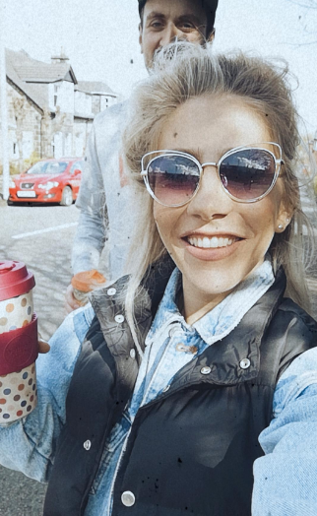
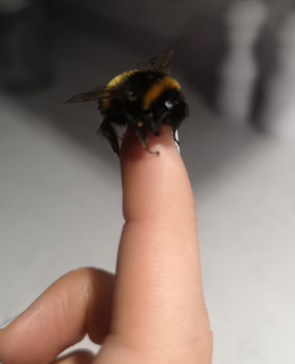

Other Curricular Areas
IDL

Fantastic suggestions so far with your IDL topic, Primary 5! Well done. I’ll be sending out a forms later on to find out which one is the most popular. If you haven’t already commented your top two, please do so today.

Geography

Follow the link below for some fun activities on maps and map reading! My suggestion for some more learning in this area would be to draw a map of your house and garden, and hide some items (do you have any easter eggs left?) Mark these on the map and see if someone else in your house can find them!

https://www.bbc.co.uk/bitesize/articles/zkngrj6

