Home Learning Experiences – Monday 20th April
Life Skills
Try and do three of these life skills each day…

- Eat your lunch outside picnic style!
- Find a comfy spot and read a book of your choice
- Organise your home learning spot (Do you have an area which you use everyday, does it have everything you need?)
- Mark something off your Happiness Bingo

Literacy
Reading

Before we start our new books can you please make a prediction about what these books will be about? Remember to explain WHY you predicted this, what clues lead you to this conclusion? Can you also write down 3 questions which you have about the book before we start reading. Please do this in your literacy jotter.

Rowlings – Starting Oranges in No Man’s Land
Walliams and Dahls – Starting the Spiderwick Chronicles
Robins – The Witches Dog and the Crystal Ball
Morpurgos – A Day in London
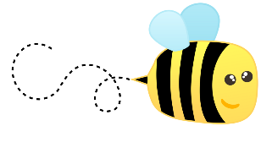
Spelling

I have attached this week’s spelling words in our blog post. Please practise these doing an active spelling strategy of your choice.

Writing

This week’s writing activity will be posted on our google classroom tomorrow!

Numeracy and Maths
Please check your google classroom for today’s Maths Home Learning.

Health and Wellbeing
I’ve LOVED keeping up with Joe Wicks over our holidays, so feel free to join in with him this morning, posting your progress with Mr Gordon.

https://www.youtube.com/watch?v=coC0eUSm-pc

Our second HWB activity this week is going to be a PHOTO challenge! I am missing seeing all your fabulous faces so I would love if you could get a photo of you doing any one activity at some point this week and send it to me (using the outlook tile on glow and sending to my email, gw17macintyrelisa@glow.sch.uk) You can do one for the week or even one a day if it is easy enough for you. Here is a photo of me practising gymnastics in my back garden. I’ve been doing LOTS of this and have even mastered how to do a handstand!

What great learning have you lovely lot been doing that you would like to share with me through a photograph?

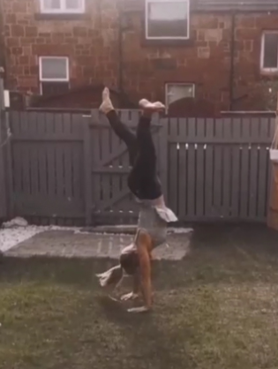

Other Curricular Areas
IDL

Wow, what an amazing job you did on your Explore Topics! I loved looking over these and will be issuing your feedback throughout the course of this week. If you haven’t already shared yours with me could you please do so.

This week we’ll be voting for our NEW IDL topic. I have added us all to an IDL classroom where I would like you to post two suggestions of what you would like our next topic to be. I’ll then narrow now the options and present you with a choice of 3-5.

Art

I have loved getting outside during the good weather so todays art challenge encourages you to get outside. Either on you walk or in your garden try and find some natural materials (or unnatural, as sadly there’s lots of that around too!) which you can take without causing too much of a disruption. Then use these materials to create your own nature art! See the photos below for inspiration.

