Home Learning Experiences – Friday 3rd April
Life Skills
Choose your own three ‘life skills’ for today and let me know what you do!

Literacy
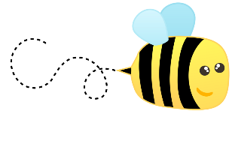
Spelling

Please ask an adult to test you on your spelling words from this week.

Writing

Please finish and submit your writing to me so that I can mark this! Thank you!

Numeracy and Maths
Please check your google classroom for today’s Problem Solving. It’s a fun one so enjoy!

Health and Wellbeing
One last day of Joe Wicks – try your hardest and enjoy!

https://www.youtube.com/channel/UCAxW1XT0iEJo0TYlRfn6rYQ

Last day for your gratitude journals too. Even though you might not be writing these down in weeks to come, please still try and practise the art of being grateful

1. I am grateful to have a garden where I can spend time outside.
2. I am grateful for coffee (you all know how much I love coffee!)
3. I am grateful for the chocolate which I enjoy eating with my coffee!

Other Curricular Areas
IDL

Please submit your ExPLORE projects today!
I cannot wait to mark them all!

Technologies

Mr Gordon has very kindly set up a Code.org course for you! You can access this through Teams and should contact him if you have any queries about logins Enjoy!

Spanish

Choose two more activities from your Spanish mat (you don’t NEED to do this task, just in case you were looking for more to do )
