Home Learning Experiences – Tuesday 31st March
Life Skills
Try and do three of these life skills each day!

- Play your favourite board game.
- Practise a new skill.
- Read your favourite book and act out your favourite part.
- Do some yoga (Cosmic Kids on youtube is amazing!)
- Make up a new game with a sibling.

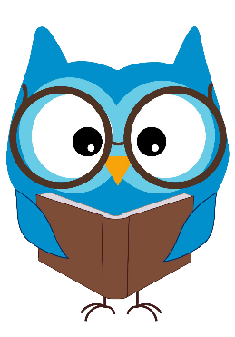
Literacy
Reading

Thank you for completing your prescribed reading pages. For today’s reading task I would like you to create a fact file on one of the characters in your book (probably the main character as it’s likely you’ll know most about them). You can submit this on the google classroom.

Writing
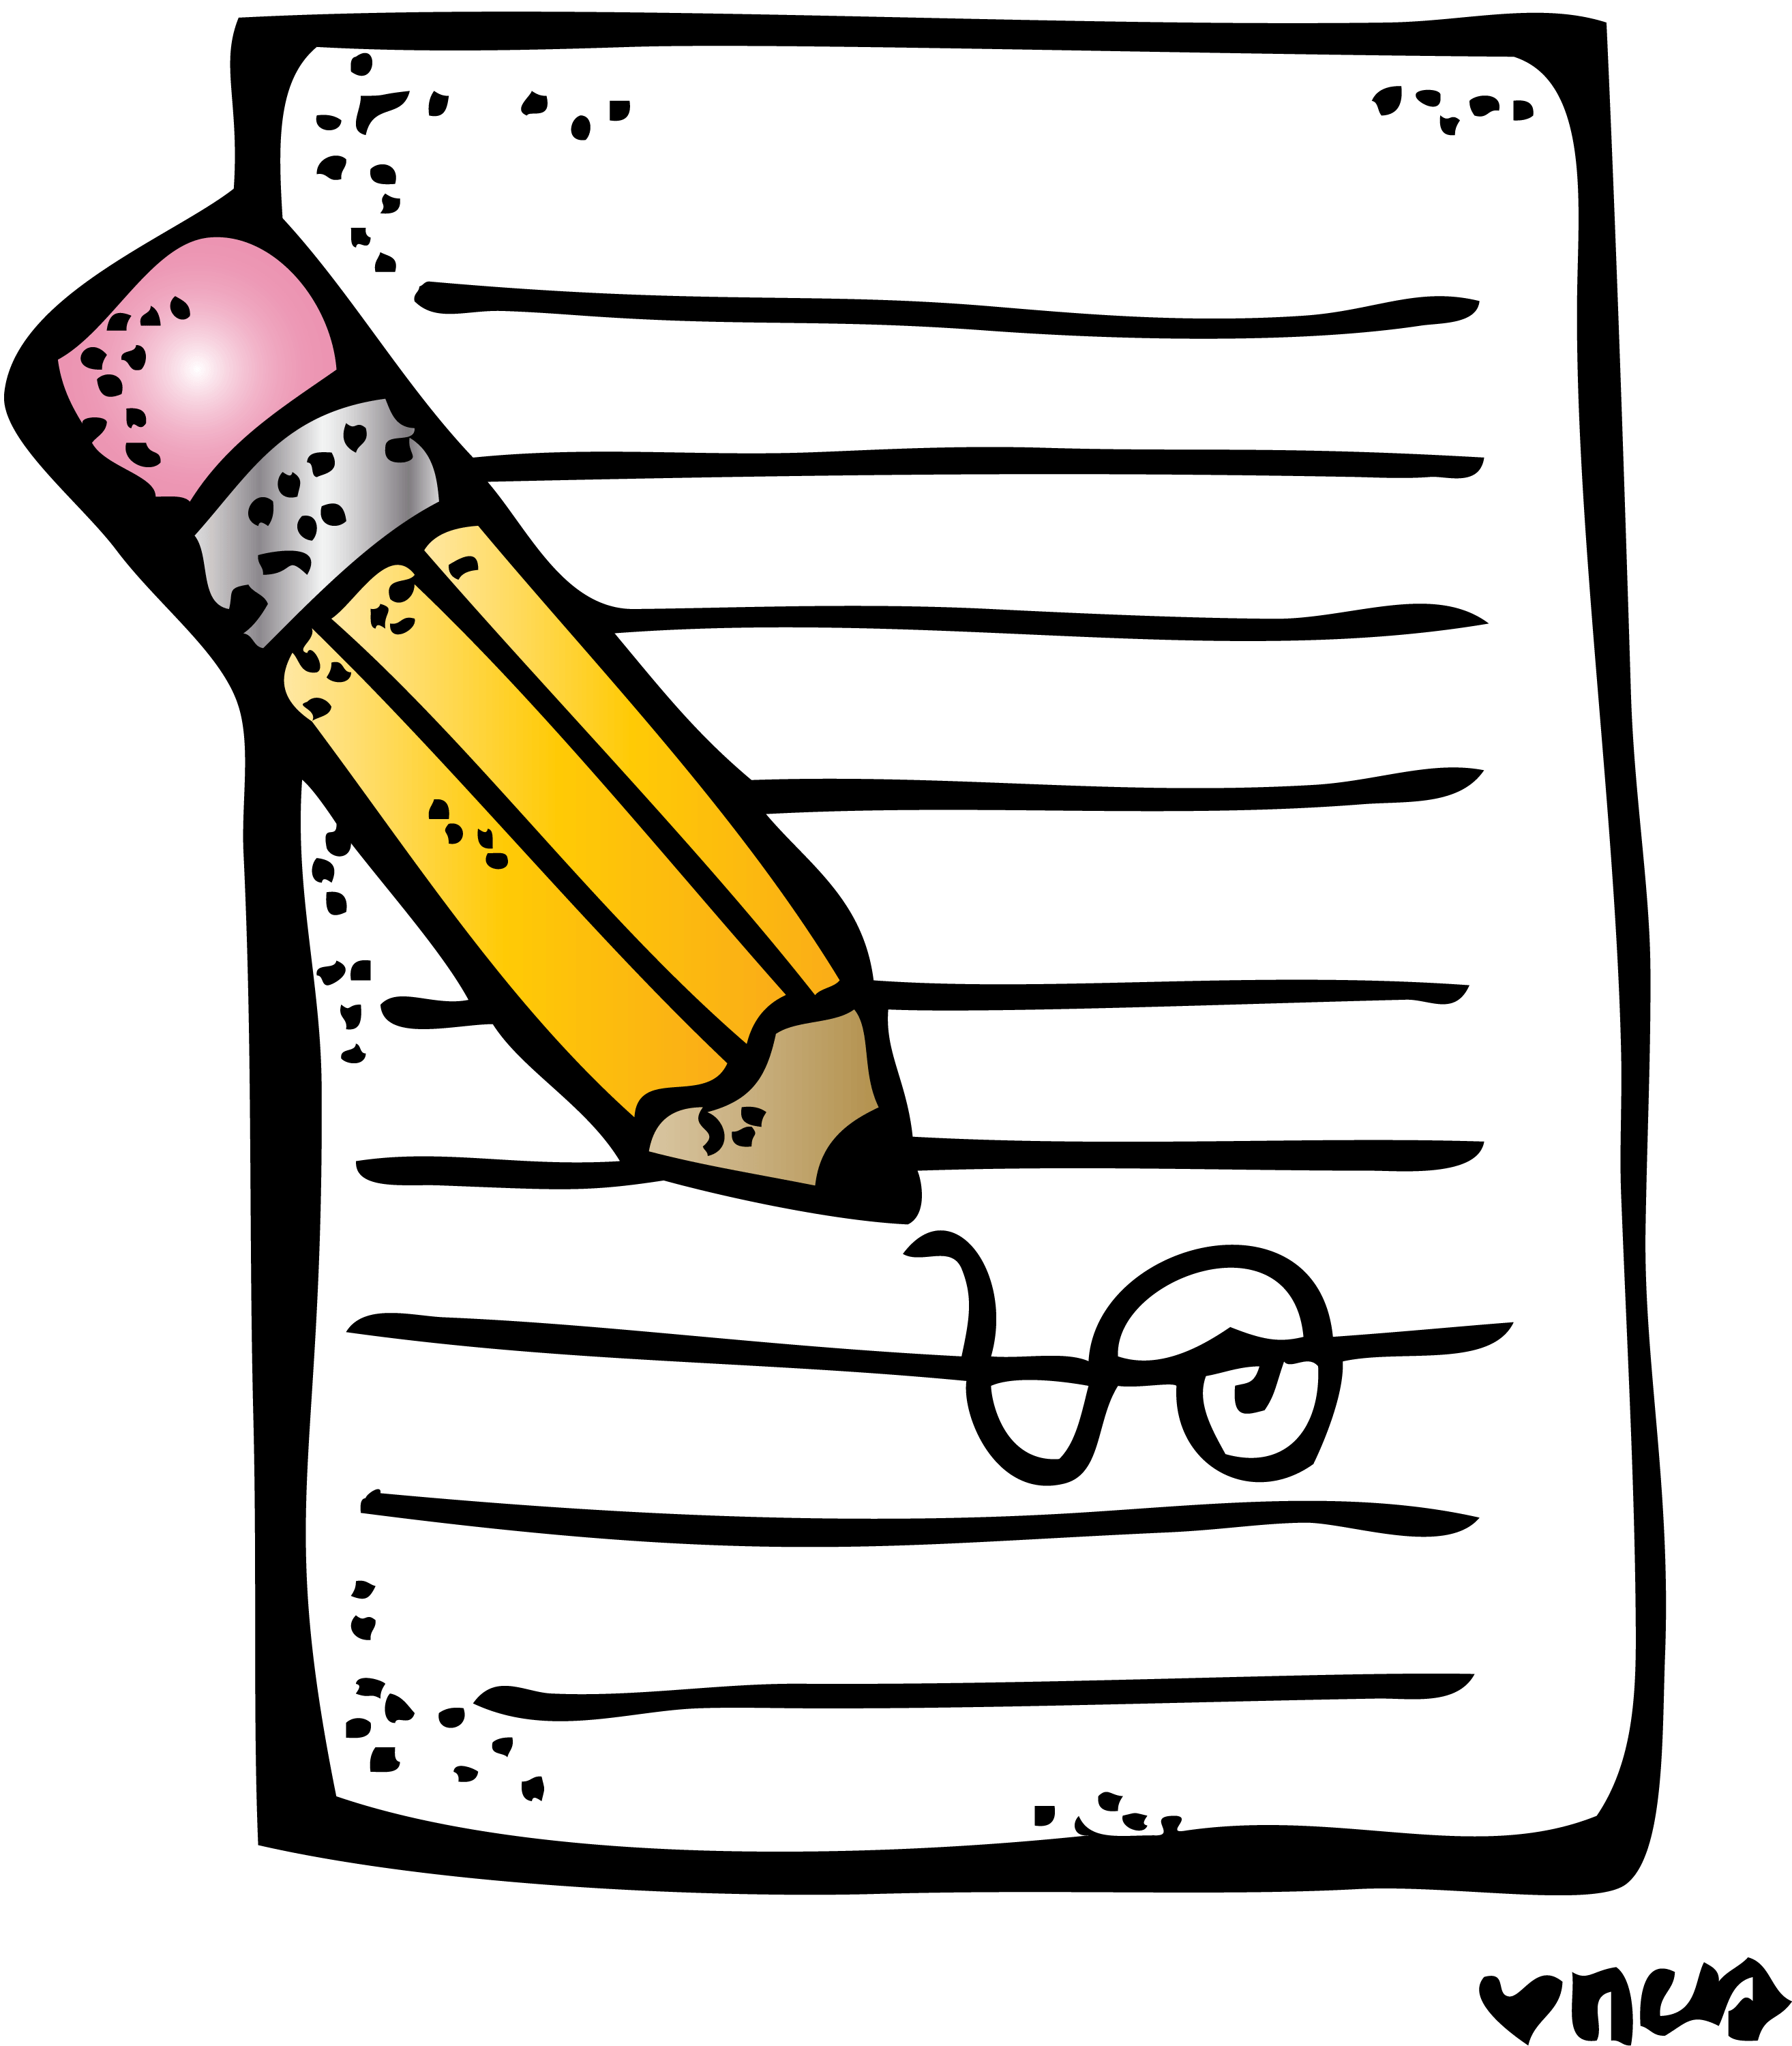
Continue with your writing task for the week. You’ll find details of this on your google classroom

Numeracy and Maths
Please check your google classroom for today’s Maths Home Learning.
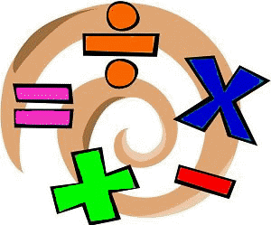

Health and Wellbeing
Joe Wicks is still available, so try that today and post about your progress on the ‘Team’!

https://www.youtube.com/channel/UCAxW1XT0iEJo0TYlRfn6rYQ

Keep working on your gratitude journals! Re-watch the video to remind you why this is so important.

https://www.youtube.com/watch?v=U5lZBjWDR_c

1. I am grateful that the weather is starting to get better because it’s nicer for our one walk a day.
2. I am grateful for the fact that I have plenty of food and get to make the dinners that I want!
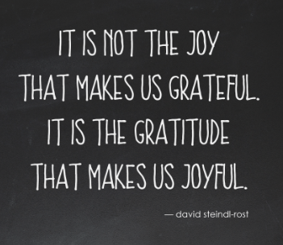
3. I am grateful for all the technology we have which allows us to carry on our learning from home.

Other Curricular Areas
IDL

Continue with your Viking explore project.

Spanish

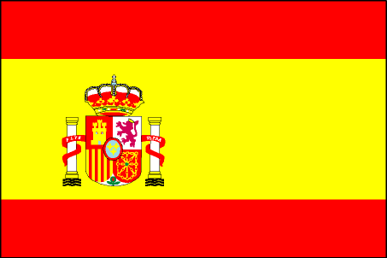
I’ve attached a Spanish Activities mat to our blog post. Choose 2-3 (or more!) of the learning experiences listed there and enjoy!

