Home Learning Experiences – Friday 27th March
Life Skills
What life skills did you do yesterday? Enjoy some today too…

- Help prepare lunch or dinner.
- Help to clear the table after a meal time.
- Make up your own exercise routine.
- Watch your favourite movie.
- Plan some enjoyable activities for the weekend.

Literacy
Reading

See our google classroom for your comprehension questions. Do you spot any questions that you created?
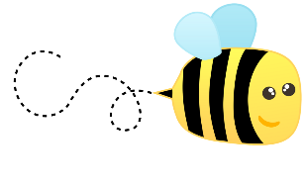
Spelling

Have an adult or sibling in your house test you on your chosen spelling words for this week. Please record this in your literacy jotters and only do it when it is convenient for your adult or sibling.

Writing
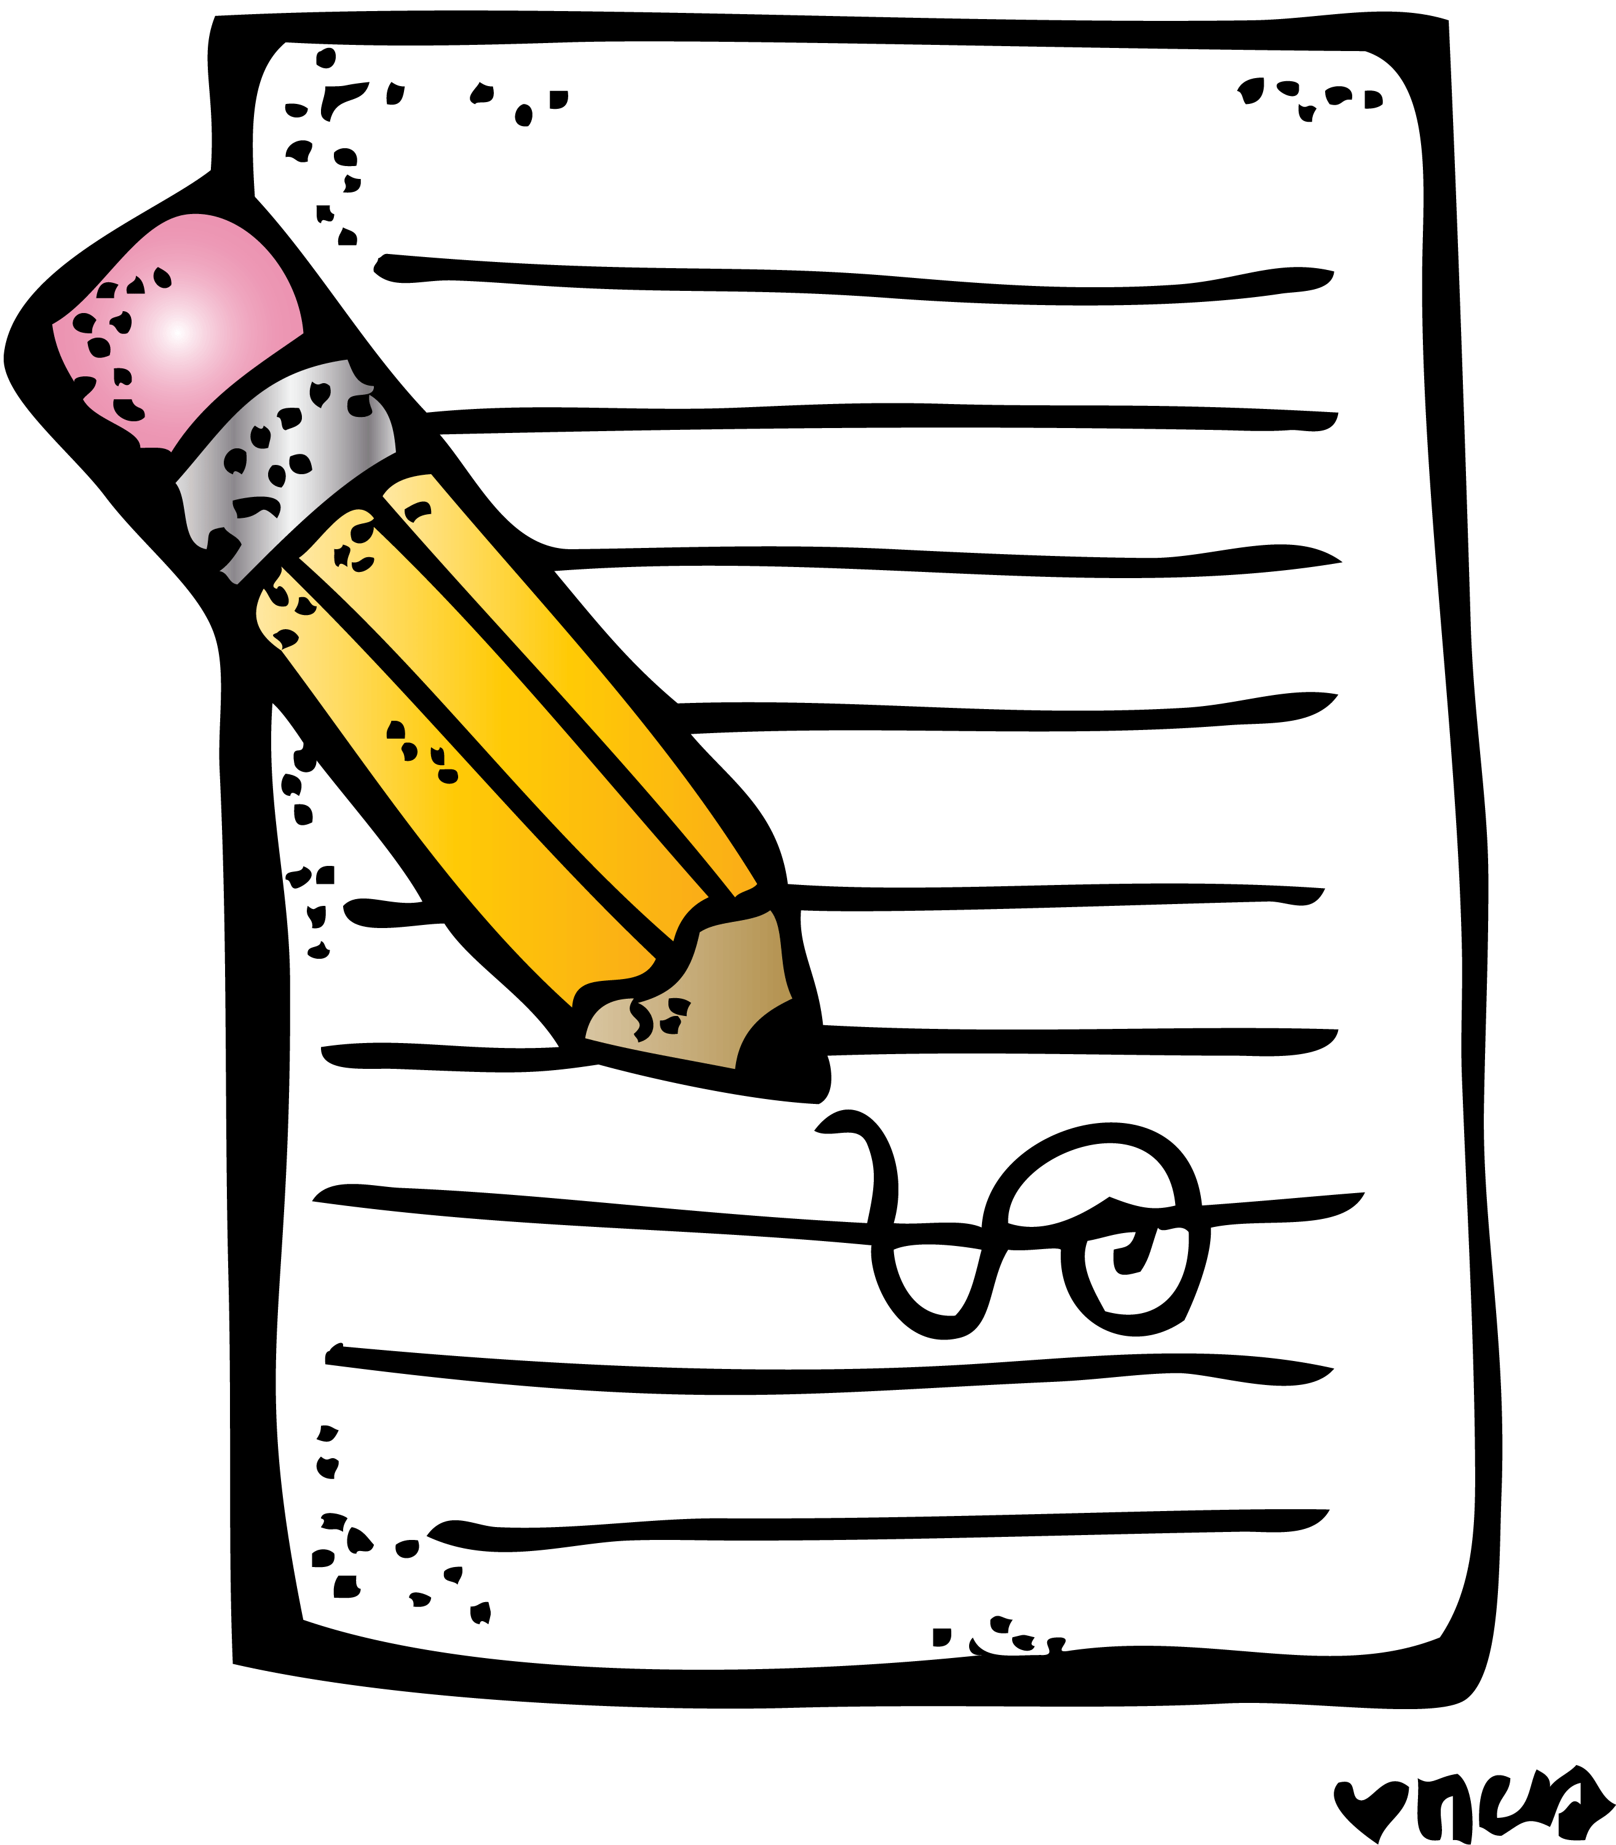
Your recount writing is due for today, so please make sure you’ve got an entry for each day.

Numeracy and Maths
Please check your google classroom for today’s Problem Solving..
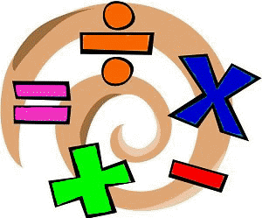

Health and Wellbeing
Our link to amazing Joe Wicks is still up

https://www.thebodycoach.com/blog/pe-with-joe-1254.html

Alternatively, choose a game or sport of your choice and play this in your garden.

Or go out and enjoy a walk! See how many different animals, birds or insects you can see. Take a note of them all! When you are outside your home, remember to follow all the Corona guidelines and wash your hands as soon as you’re back.

Other Curricular Areas
Science
Enjoy your daily science video using the link below…

https://www.glasgowsciencecentre.org/gsc-at-home

IDL

Continue with your Viking explore project.

Also, if there is any work from this week which you have not finished then now is your opportunity!

