Home Learning Experiences – Thursday 26th March
Life Skills
What life skills did you do yesterday? Enjoy some today too…

- Help prepare lunch or dinner.
- Help to clear the table after a meal time.
- Make up your own exercise routine.
- Watch your favourite movie.
- Plan some enjoyable activities for the weekend.

Literacy
Reading

Write a summary about what you have read already. Remember, a summary should only be in the main ideas of the books, and not a lot of the extra information. You can use the Somebody Wanted But So Then approach. Comprehension questions which you created are coming at you tomorrow!

Spelling

I LOVED seeing the creative way you all spelled your words on Wednesday. Keep up the creativity. Please choose an active spelling strategy of your choice to practise your words. We will be having a spelling assessment tomorrow, so make sure you know them all.

Remember writing is due for Friday and should be done continuously throughout this week either in your literacy jotter or typed using digital technologies.

Numeracy and Maths
Please check your google classroom for today’s mental and written maths.

Health and Wellbeing
Our link to amazing Joe Wicks is still up!

https://www.thebodycoach.com/blog/pe-with-joe-1254.html

Alternatively, you can create your own home work out using this ‘Spell Your Name’ grid. Not only do I want you to spell your OWN name, but I would like you to spell the names of all the people in your family. Plus I would like an adult to come up with two random words which you also need to spell out!
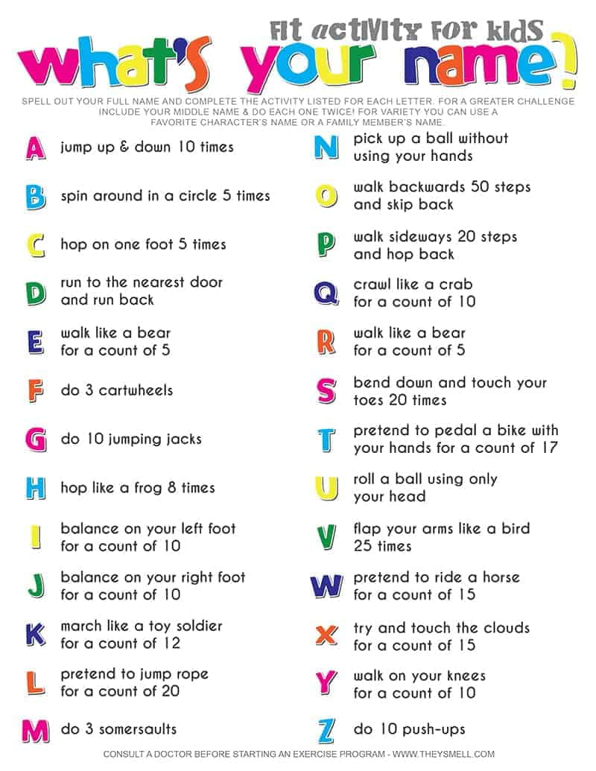

Also please take time to finish your handwashing adverts/videos. I’ve loved seeing some of these already so if you haven’t finished it yet please do so and send it to me if you used tech!

Other Curricular Areas
Science
I’ll keep up the Glasgow Science Centre for your enjoyment... Remember that you can record your learning in your IDL jotter (or really in any way that you’d like to!)

https://www.glasgowsciencecentre.org/gsc-at-home

IDL

As there’s only a week and a bit left of this term, we’ll be concluding our amazing Vikings topic with an Explore topic. You can choose any aspect of Vikings to research further in order to create something of your choice, whether that is a sway, a PowerPoint or a model! I’ve attached the explore slides to this blog post for you to refresh your memory of what is expected at each stage of the process. These will be due for next Friday (3rd April).

I’ll also be gathering suggestions on what we should do for our next topic, so have a discussion with people at home about what you would be interested to learn about and what will work with Home Learning.

Digital Technologies

Log on to Code.org and pick up from where you left off

