Home Learning Experiences – Tuesday 24th March
Life Skills
What life skills did you do yesterday? Enjoy some today too…

- Ask all members of your family how they are doing today.
- Help set the table before a meal time.
- Help with a household chore
- Help a sibling with a task.
- Mark something off your ‘Happiness Bingo’
- Sit quietly for 20 minutes and read a book of your choice.

Literacy
Reading

Grab your new book and before you start reading, make a prediction of what you think the book will be about. Remember to use the front cover, blurb and contents page to help you get an idea.

When you have made your prediction design a new front cover for you book in your literacy jotter. Give it a new title based on what your prediction was! Remember the normal standards for jotter layout: full date and title, both underlined with a ruler.

Rowlings – Dog Lost
Walliams and Dahls – Invasion
Robins – Ollie
Morpurgos – The Surprise
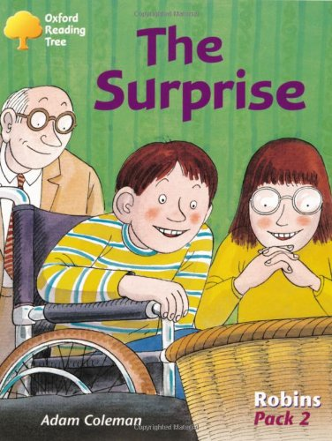
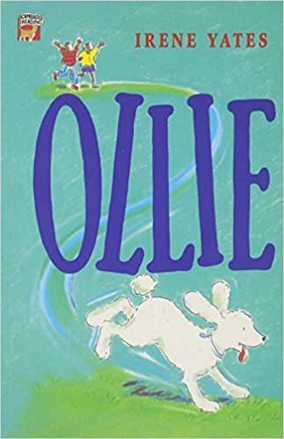
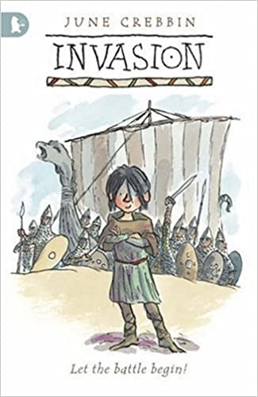

Remember writing is due for Friday and should be done continuously throughout this week either in your literacy jotter or typed using digital technologies.
Numeracy and Maths
Using a calculator can you please mark your four a day from yesterday.

You will find your mental and written maths on our google classroom today!
Health and Wellbeing
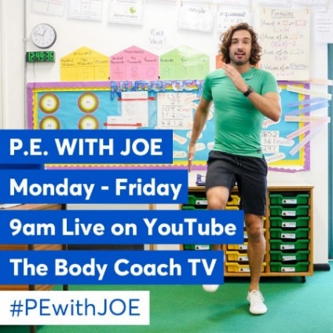
Who tried it yesterday?! Enjoy this Joe Wicks 30 minute workout which goes live at 9. Remember to share your progress on the ‘Team’.
https://www.thebodycoach.com/blog/pe-with-joe-1254.html

Other Curricular Areas
Science
Glasgow science centre have still got their live videos to please check in with them using the link below! You can record what you’ve learned from the video in your IDL jotter.

https://www.glasgowsciencecentre.org/gsc-at-home

Art
Please use the visual element of COLOUR, LINE and PATTERN to design the front cover of all of your jotters. These are yours and will be yours for the next few weeks and months so please make sure that your design is neat, tidy and representative of the good work which will be inside them! They should also state which jotter is which: Literacy and English, Numeracy and Maths or IDL (Interdisciplinary Learning).

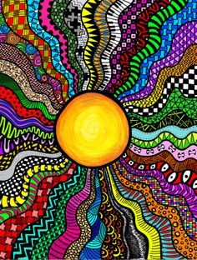
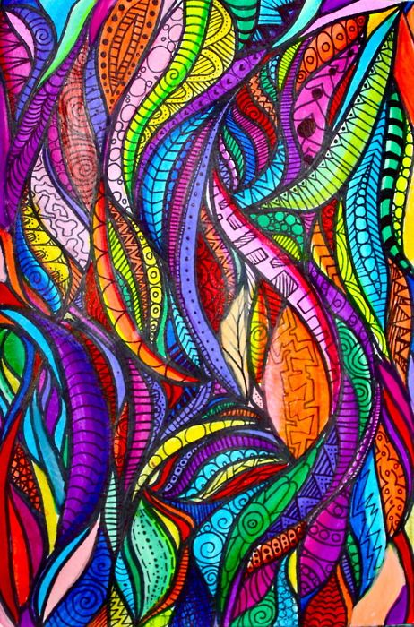
Take some pictures and send them to me through my glow email! I will pop some of these designs on the class blog for others to see and be inspired by!
