Home Learning Experiences – Monday 23rd March
Life Skills
Now that we will be learning from home for the next few weeks, I want to make sure that we are practising some key life skills! Each day you will have a selection of tasks in this first ‘curricular area’. Please complete at least three of them each day. If you have any other suggestions for what learning we could include in ‘Life Skills’ please send an email to my glow account!

- Ask all members of your family how they are doing today.
- Help set the table before a meal time.
- Help tidy up after a meal time.
- Help a sibling with a task.
- Enjoy a healthy breakfast.
- Tidy your room or a room in the house.

Literacy
Weekly Writing –

Keep a diary of your first week of home learning. Write a recount of what you have done each day. See the Home Learning Literacy Google Classroom for more information on this. This Classroom will be live from 10am this morning.

Numeracy and Maths
Grab a dice, make your own (think about our knowledge of nets of 3D objects!) or use this virtual dice. Roll it to make your own 4 a day. Remember, you should have one of each operation and for subtract, the larger number must go on top!
Please record this in your maths jotter. Date and title at the top of the page please!

https://www.google.com/search?q=virtual+dice&spell=1&sa=X&ved=2ahUKEwinm9eckrDoAhWmQkEAHRGbCscQBSgAegQIDBAm&biw=1366&bih=622#spf=1584950903728

Looking for more maths? Enjoy 20 minutes of SumDog!
Health and Wellbeing
Enjoy this Joe Wicks 30 minute workout which goes live at 9. You don’t need to join in in live time as the video will stay up after the work out is over.

Mr Gordon will be joining in with you from his own home and has set up a ‘Teams’ for you to share and track your progress.
https://www.thebodycoach.com/blog/pe-with-joe-1254.html

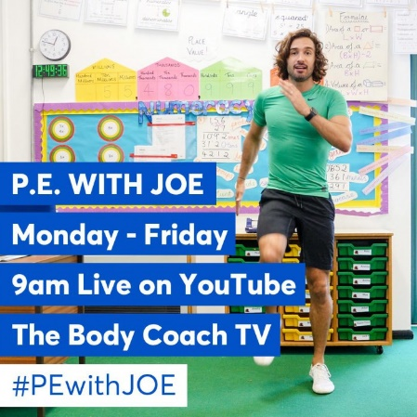
Other Curricular Areas – Science
Enjoy this video from the Glasgow Science Centre about how to make your own lava lamp from home. Some videos which have already been streamed can also be watched and enjoyed! All can be found following this link.

https://www.glasgowsciencecentre.org/gsc-at-home

Can you write down what you learned in your IDL jotter. Remember to give a date and title for each entry.

Most importantly, have a great day everyone!

