This week’s homework

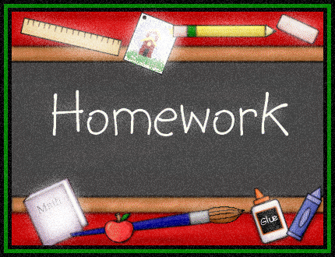 |  | - Primary 3  Homework + News  - 11.12.2017  Nativity performance week!
 | Other | Other news and information

Spelling
n/a

Reading + Writing
OPTIONAL
- Do some personal reading with a book about weather, winter or Christmas.
- Help at home by writing Christmas cards, gift tags or a shopping list
Maths
10 minutes of Education City (Homework option) each day please.

Other
Nativity
We are looking forward to performing and showing off our singing and speaking this Wednesday and Thursday.
If you haven’t already done so please organise your clothes for the performances (as per e-mail).
- Black/dark trousers or leggings
- Black shoes

Please be back in school at 6pm on Thursday evening!

Coming up…
- Tuesday 19th December – P3 + P4 party. Wear party clothes that day.
- Wednesday 20th December – Term 2 Winning House Reward Event
- Wednesday 2oth December – Wizard of Oz Hopscotch Theatre group

THIS WEEK…
- ‘Grandparents’ Nativity performances at 9am and 2pm on Wednesday
- Further nativity performances at 2pm and 6:30pm on Thursday

