This week’s homework

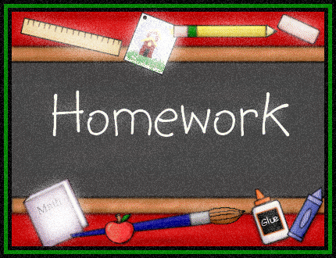 |  | - Primary 3  Homework + News  - 04.12.2017  The Nativity countdown is on!
 | Other | Other news and information

Spelling
M: Write each word twice and clarify (orally)
T, W, Th: Choose an active spelling task each day

Reading + Writing
OPTIONAL
- Do some personal reading with either your group reader, a book about weather, winter or Christmas.
- Ethan’s idea: Write a short story using your Read, Write, Count story cubes

Maths
10 minutes of Education City each day please.

Other
Nativity
We are making wonderful progress!
Please keep practising and remember to organise your clothes for the performances (as per e-mail).

Writing
Your child has already started to create a superhero they will write about in class this week. Please talk to them about their ideas.

BOOK WEEK SCOTLAND
Thank you for supporting us last week. We had a great time focusing on reading for pleasure. More parent reading workshops and sessions to come. Watch this space!
Further activities linked to the First Minister’s Reading Challenge to follow soon.

ST ANDREW’S DAY
Many thanks to Arlo’s mum for inspiring us with her talent and knowledge of Scottish music.
THIS WEEK…
- If you didn’t make it to the fair to buy your Christmas craft you can bring in £1 to get it in class
- Music with Mrs Carey
- Committee meetings on Wednesday

