This week’s homework

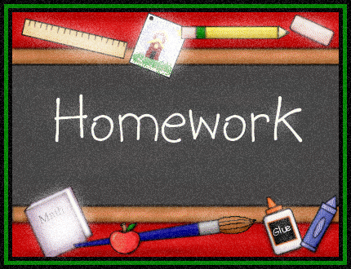 |  | - Primary 3  Homework + News  - 27.11.2017  Book Week Scotland
 | Other | Other news and information

Spelling
No homework this week!
Reading
We’ll be reading Scottish texts in class to coincide with St. Andrew’s Day on Thursday.
See below for optional reading tasks linked to Book Week Scotland and the First Minister’s Reading Challenge.
- Visit the library
- Read a favourite book from when you were younger
- Read in an unusual place (e-mail or tweet a photo to the school if you like)
- Read to your family
- Do activities from your Read, Write, Count bag
Maths
Keep playing Sumdog! We are currently the highest ranked Braidbar class in the competition! 10 minutes each evening.

Other
Nativity
Please learn your spoken lines by heart. Try to deliver with confidence and good expression.
Please practice songs 1, 4, 7 and 8.

Costume information and request to follow.
BOOK WEEK SCOTLAND
We have lots planned for this week
- Please join us in class at 2:30pm on Tuesday 28th Nov for a Read, Write, Count gifting session
- Please join us on Friday 1st Dec at 2:45pm where I ask that you read some books to the children
- A few surprise visitors will be coming in to read to us!
ST ANDREW’S DAY – 30.11
This Thursday we will enjoy some Scottish music with Arlo’s parents. Try to wear something tartan that day!
THIS WEEK…
- First Minister’s Reading Challenge to be introduced by the Librarians on Wednesday
- If you didn’t make it to the fair to buy your Christmas craft you can bring in £1 to get it in class

