This week’s homework

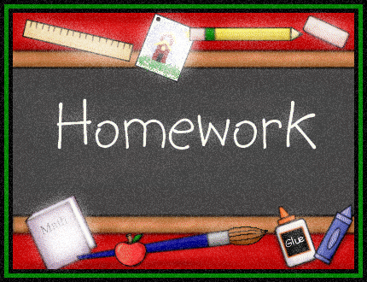 |  | - Primary 3  Homework + News  - 20.11.2017  £401 raised for Children in Need!  Well done!
 | Other | Other news and information

Spelling
M: Write all words twice and clarify them (orally)
T, W, Th: Choose one activity each night from your sheet.

Reading
Thank you for your continued support in this area.
M: Assembly words
T: Assembly words
W: Break!
Th: Nativity words

Maths
Since the coming weeks will be focused on reading and learning spoken parts and songs for our nativity we ask that reading be your main focus. However you may access both Sumdog and Education City to consolidate maths skills. You are registered for a Sumdog competition beginning Friday 24th. Good luck!
Other
Nativity
You have already received information regarding tickets and from the end of this week your child will have a script and song words. This will be their main homework for the next few weeks. Follow other blog links for further info.
BOOK WEEK SCOTLAND
We have lots planned for next week (27.11 - 01.12)
- Please join us in class at 2:30pm on Tuesday 28th Nov for a Read, Write, Count gifting session
- Please join us on Friday 1st Dec at 2:45pm where I ask that you read some books to the children
- A few surprise visitors will be coming in to read to us!
ST ANDREW’S DAY – 30.11
Next Thursday we will enjoy some Scottish music with Arlo’s parents. Try to wear something tartan that day!
THIS WEEK…
- Class assembly at 9:15am on Wednesday
- Dress down and bring tombola donation on Friday
- Christmas fair on Saturday at 12:30pm

