This week’s homework

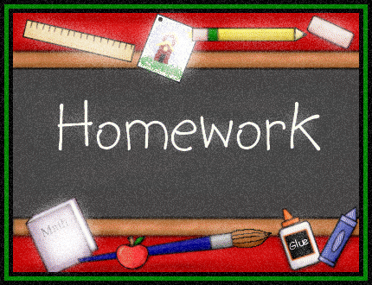 |  | - Primary 3  Homework + News  - 13.11.2017
 | Other | Other news and information

Spelling
M: Write all words twice and clarify them (orally)
Tues, Wed and Thu: Choose an active spelling task each night from the sheet provided. Please keep this sheet for future weeks.

Reading
Please practice your words for our assembly next week. Remember we are trying to excite our audience by speaking with clear expressive voices.
Do some personal reading if you have extra time.

Maths
Our focus this week is assembly preparation but if you wish you can do some practical maths tasks like telling the time, estimating and measuring things around the house, going on a 2D or 3D shape hunt etc. You can also access Sumdog and Education City as normal.

Other
Talking + Listening
Successes and Achievements
Please see printed sheet for guidance and task.

PLANNING OUR LEARNING
Thank you for the facts and questions you collated with your children last week. This will inform our learning about the weather and the sun and moon.
CLASS ASSEMBLY
We will be the next class to share our learning at an assembly. Please come and join us on Wednesday 22nd November at 9:15am.
PARENTS’ EVENINGS
Thank you for your feedback and continued support.
THIS WEEK…
- Ragbag collection ends Wednesday morning
- Anti-Bullying Week
- Children in Need on Friday - £1 to wear spots, bake sale 20p-50p and guess Pudsy’s birthday 20p

